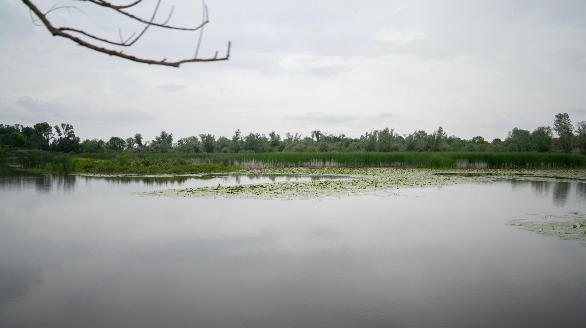
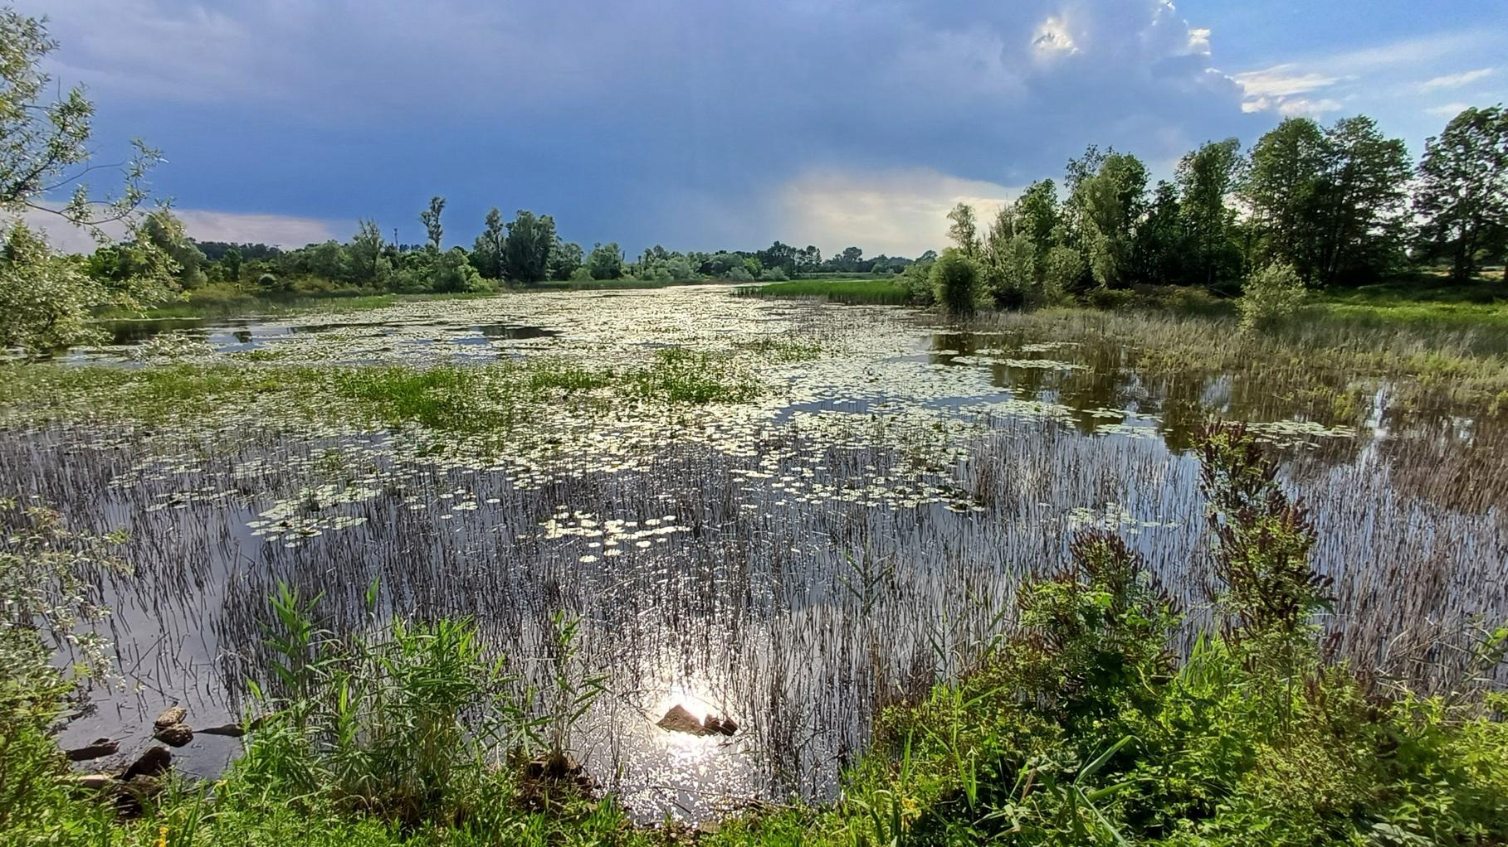
Development of an ecosystem restoration plan to ensure biodiversity conservation in the Tišina protected landscape in Šamac

Restoration plan for Tišina PA

 | 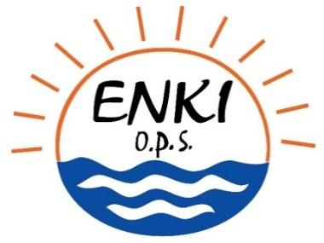 |  | 
 | Funded by United Nations  Development Programme (UNDP)

Report details
This report represents restoration plan which is the main output of the project Development of an ecosystem restoration plan to ensure biodiversity conservation in the Tišina protected landscape, which is financed by the United Nations Development Program in Sarajevo under contract award number 10201197 and realized by the consortium composed of Enki, o.p.s, ITI consulting d.o.o., IBIS Inženjering, d.o.o. and GRID.
Team of authors:
Marek Baxa, Michal Šereš, Azra Muhović, Maja Čolović Daul, Anna Huryna, Denis Fontana, Petra Hesslerová, Petar Begović, Petr Dosoudil, Jan Pokorný, Nikola Milanović.
Edited by:
Marek Baxa and Maja Čolović Daul
Due to date:
December 2, 2024
Prepared in:
Třeboň (CZE) and Sarajevo (BiH)
Content

1. Introduction 5
2. Methodological approach to the preparation of the restoration plan 6
Nutrient ratio 9
Food chain 9
Diverse morphology 9
Regulated fishery 10
3. Definition of the goal of restoration 11
3.1. Wetland restoration priorities 11
3.1.1. Priorities in relation to the protection of endangered habitats and populations 12
3.1.2. Priorities in relation to the identification of wetland functions with an assessment of current status and trends 13
3.1.3. Rapid assessment of ecosystem services 15
3.1.4. Establish local restoration priorities in relation to the river basin’s management plan and goals 20
3.2. Wetland restoration operational objectives 21
3.2.1. Conservation objectives 21
3.3. Final ecological status 21
3.3.1. Areas of periodic flooding 22
3.3.2. Proposal of zonation 25
4. Proposed restoration plan 27
4.1. Restoration measures 27
4.1.1. Removal of sediments in water bodies 27
4.1.2. Building barriers and dams in Mala and Velika Tišina 30
4.1.3. Building additional water source for wetland system 32
4.1.4. Clearing of Žandrak 36
4.1.5. Introducing specific management rules 37
4.1.6. Optimizing land cover 39
4.1.7. Changing land use in protected area 39
4.2. Timeline for the implementation 39
4.2.1. Removal of sediments in water bodies 39
4.2.2. Building barriers and dams in Mala and Velika Tišina 40
4.2.3. Building additional water source for wetland system 40
4.2.4. Clearing of Žandrak 40
4.2.5. Introducing specific management rules 41
4.2.6. Optimizing land cover 41
4.2.7. Changing land use in protected area 41
4.2.8. Overall timeframe and costs 41
4.3. Best methods for conducting restoration measures 42
5. Post-hoc monitoring 44
6. Evaluation of the restoration plan 46
6.1. Simplified SWOT analysis 46
6.1.1. Removal of sediments in water bodies 46
6.1.2. Building barriers and damns in Mala and Velika Tišina 46
6.1.3. Building additional water source for Wetland system 46
6.1.4. Clearing of Žandrak 47
6.1.5. Introducing specific management rules 47
6.1.6. Optimizing land cover 47
6.1.7. Changing land use in protected area 48
7. Conclusions 49
8. Annexes 50
9. References 51

Introduction
The Tišina Protected Area is a unique wetland ecosystem created by the natural forces of the Bosna and Sava rivers, whose meandering beds under the influence of lateral erosion have created a complex of watersheds, oxbow lakes and old riverbeds connected to groundwater. The Mala Tišina, Velika Tišina and Odmut wetlands, located on the right side of the Sava, are the remnants of ancient meanders formed by tectonic shifts that led to the formation of terrain depressions. These wetlands, integrated into the hydraulic system of the Sava, are crucial for the management of the internal and external flow of water.
Tišina is characterised by a flat, lowland landscape shaped by erosional and depositional forces and lies within the Šamac - Posavina structural unit of the Pannonian Basin. Its terrain has an average altitude of 85 m, almost imperceptible slopes, water-holding substrates and a mixture of fluvial and lacustrine sediments supporting a complex hydromorphic soil structure. The wetland complex includes ponds, floodplain forests, wetlands and channels and forms an ecologically important habitat in the middle of the intensively cultivated and densely populated Posavina region.
The rich biodiversity of Tišina is well documented, with recent studies recording 175 plant species, 123 bird species and 47 amphibian and reptile species and 21 fish species. The area is a critical breeding ground for fish, with Cyprinide species such as tench, perch, bream and asp, as well as commercial fish such as catfish, pike and carp. A total of 21 species of fish have been observed in the wetlands. The area is also home to diverse populations of amphibians and reptiles, including protected species such as the European pond turtle (Emys orbicularis), the fire bellied toad (Bombina bombina) and the common toad (Pelobates fuscus). Birds also thrive here, with 123 species recorded, 87 of which are strictly protected and 20 protected under national and international regulations. The Tišina area includes six habitats classified as threatened under Natura 2000, which underlines its importance for European nature conservation efforts.
In addition to the undeniable importance of the area for biodiversity, it is essential to emphasize that the significance of wetlands is also reflected in their flood-protection and regulatory roles, which are especially important for the local population given that the broader area is prone to flooding, and agricultural activities are the primary activities of the local community. A balanced ecosystem, preserved and enhanced, directly contributes to improving the quality of life for the local population through numerous ecosystem functions and resources.
In recent decades, a trend of continuous drying up of water bodies in wetland systems has been observed. In the case of Mala Tišina, we can already speak of a complete collapse of the wetland system. In the case of Velika Tišina and Odmut there is a significant fluctuation of water level, which may cause complete drying up at the end of the summer season. The whole protected area is exposed to a combination of factors that pose a serious risk to the future development of species richness. In addition to the collapse of the hydrological regime, other factors such as increasing agricultural intensity, deforestation, or loss of natural forest vegetation and tree canopy, increasing alien species invasion, reckless sediment removal, etc. are threatening Tišina.
In order to avoid the threat of Tišina's disappearance, it is necessary to take a decision as soon as possible and start actions related to the restoration of this rare wetland system. The Tišina wetland complex, with its combination of flood control functions and critical biodiversity, remains an important ecological and hydrological resource. The natural features of the protected area and its diverse habitats highlight the need for its continued protection and thoughtful restoration to maintain fits ecological and cultural significance. This document is intended to serve as a brief description of the measures that are recommended for the gradual restoration of all the functions of this rare wetland ecosystem.

Methodological approach to the preparation of the restoration plan
During 2024, intensive survey work was carried out to examine and assess all existing relevant sources of information about the Tišina Protected Area and to supplement it with missing information through fieldwork. A brief description of all the documents studied is included in Annex 1 to this report. The results of the field surveys carried out in preparation of the Restoration Plan are also included in Annex 2 - Annex 4. The following text thus serves as a methodical approach that led to the definition of the exact plan for the restoration of the Tišina PA.
In order to accurately define the approach to designing appropriate restoration measures for the area, basic assumptions had to be identified based on existing knowledge of the area. These assumptions are listed below in Box 1.
Box 1: List of assumptions
- The monitored site is a very heterogeneous and complex area that has been regularly flooded in the past. Due to technical measures, flooding no longer occurs in its natural mode as it used to.
- There is no specific conservation objective or list of conservation objectives defined for the area.
- Water scarcity in the area is caused by a combination of a number of factors, and it is not known how significant any particular factor is.
- If no action is taken, it can be assumed that the entire wetland system and its complexity will gradually collapse.

In principle, the assumptions formulated in this way have very clearly defined the boundaries for setting key investigation objectives, the achievement of which is essential for unbiased proposals for measures. These investigation objectives are listed in Box 2.
Box 2. List of investigation objectives
- To map the area in detail from the perspective of land use and landcover.
- To map the hydrology and hydrogeology of the area in detail.
- To define the causes of water loss from the area and to attempt a basic hydrological balance.
- To describe the variations of temperatures in the territory.
- To define the controlling factors of change in the territory.
- To estimate the importance of specific factors causing water loss.
- To define the conservation objectives of the area.

When proposing the measures, the first step is to proceed from the basic assumption that the defined protected area is a wetland with a high potential for biodiversity maintenance and development. The working hypothesis that the project wanted to confirm were that The gradual loss of water from the area is the result of a number of reasons, including the following:
- Stormwater and flood control management structures in the surrounding landscape
- Land use practices
- Average annual increase of temperatures/decrease of precipitation
These causes of water loss are such a major negative factor, which significantly threatens the wetland itself and the wetland-associated communities, that a key aspect of restoration is to bring water back into the area quickly and then try to maintain it in the landscape for as long as possible through a combination of measures. Supporting water-dependent biocoenosis can be seen as a subsidiary, rather than a minor, issue in this respect. This statement is based on the knowledge of how wetland ecosystems of shallow eutrophic reservoirs are functioning, whereby the wetland system of Velika Tišina, Mala Tišina and Odmut bears all the characteristics of shallow eutrophic waters.
As previously mentioned, the presence of water is of course a fundamental criterion for supporting water-dependent biodiversity. However, as other examples from around the world show (e.g. Lake Naivasha in Kenya, or Vizir and Rod ponds in the Czech Republic) biodiversity increases with the higher riparian coefficient and more abundant mosaic of littoral zone with a gradual transition from water to shore and vice versa. In the so-called transition zone, the ecotone, diverse communities with different life strategies meet to adapt to rapid changes in environmental conditions. Therefore, ecotones, not only in the literature but also as examples of good practice, are described as a building block for biodiversity. In Figure 1 it can be seen how much potential for biodiversity development a naturally shaped and wide littoral zone (ecotones) can have. For this reason, it can also be conscientiously argued that water level fluctuations are not a negative and undesirable phenomenon in Velika Tišina, but on the contrary can define its richness to a large extent.
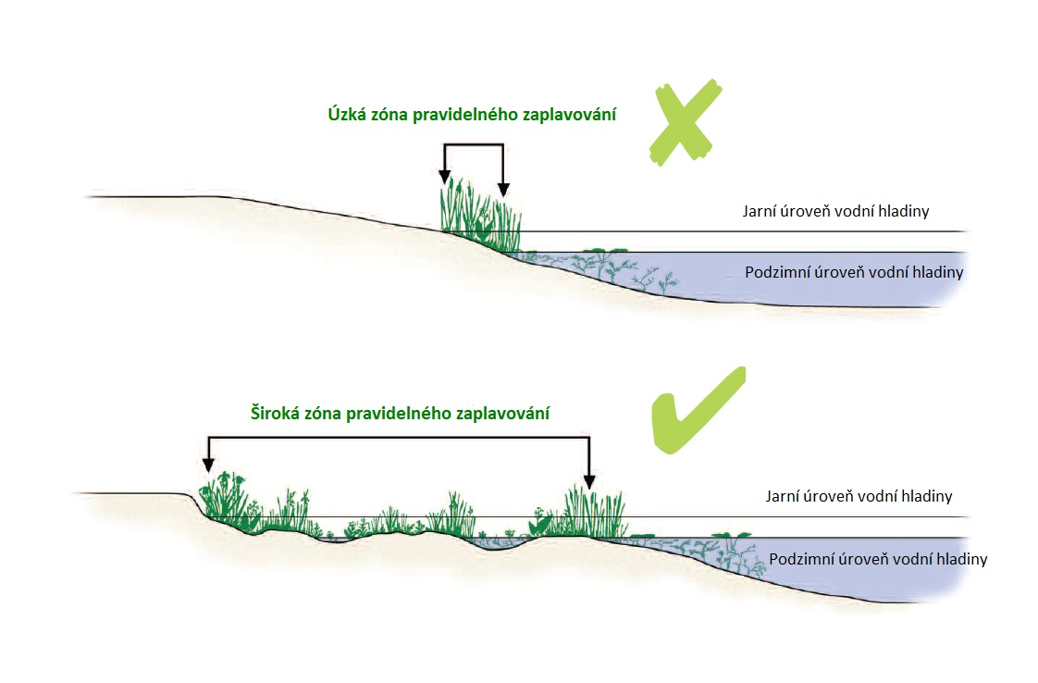
Narrow periodically flooded zone
Wide periodically flooded zone
Water level in spring
Water level in autumn
Water level in spring
Water level in autumn
Figure 1. Schematic representation of the correct function of the literal band during level fluctuations (https://mokrady.wbs.cz).

Another benefit of such a morphologically shaped littoral is the ability to retain water longer in the landscape. The volume of water retained in littorals is not decisive in terms of the total volume, but mainly in terms of more sustainable conditions for the survival of biocenosis in a given season due to wider flooding areas as depicted on Figure 1. And, as suggested earlier, most communities have evolved life strategies that allow them to survive in periodically flooded or drying habitats. The presence of an extensive ecotone promote water infiltration because the maintenance of humid conditions (not necessarily permanent flooding) supports edaphic biocenoses (plants and bacteria) that maintain high soil permeability and favour aquifer recharge. From the above description, one key message emerges - the ecosystem of Velika Tišina, Mala Tišina and Odmut should not be permanently flooded to the maximum water level. The maximum water level may be reached in the spring phases of the season at the time of hydrological maximum, i.e. when it is easy to recharge, and water may be gradually lost from the system by evapotranspiration of slow infiltration to the soil. On the other hand, the opposite extreme is not desirable, i.e. to experience the dramatic drying up that has been observed in recent years (example in Figure 2).
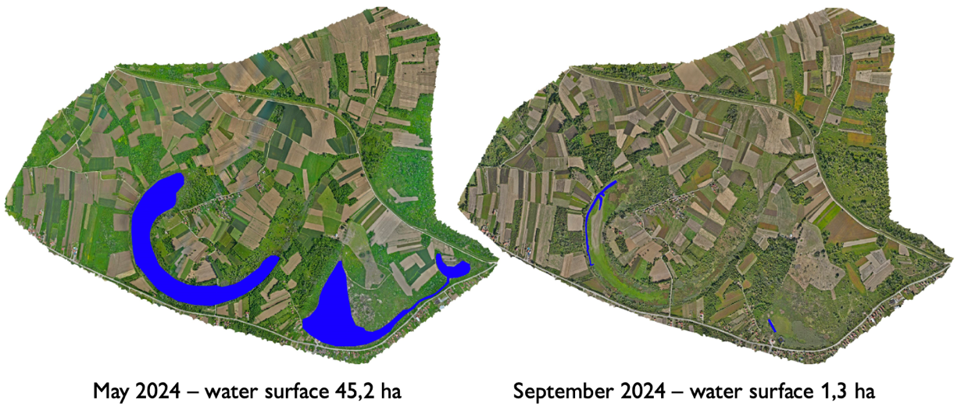
Figure 2. Change in water surface area cover in spring and autumn 2024 (Source: Authors)

The morphological characteristics of the terrain (relief) are a direct consequence of the geological structure of the terrain, tectonic activity and geomorphological processes that participated in the formation of the terrain. The wetland area is located in the alluvial plain of the Sava River, east of the confluence of the Bosna River. The Quaternary alluvial plain was formed in the fluvial process, i.e. by the work of the river flow, which leads to polycyclic deposition of various sediments (riverbed facies, oxbow facies and floodplain facies). The water bodies of Mala Tišina, Velika Tišina and Odmut are relics of the former river flow of the Sava, which in the process of meandering moved to the north and additionally cut into the deposited sediments, which left the wetlands and the surrounding terrain at higher altitudes.
Historically, the Tišina complex was fed by various water sources, which combined groundwater springs, inflows of rainwater and various surface tributaries, especially the natural channel Žandrak. However, during the last century, several major landscape infrastructure changes have been developed in connection with flood protection and the whole complex has become dependent mainly on groundwater springs. However, as the above information and details of the hydrogeological survey (Annex 2) show, soils and sediments are derived from complex alluvial dynamics. It is therefore now difficult to map and identify water sources and water losses.
The main driving factors for the change of the water regime in the area of interest have already been mentioned above at the beginning of chapter. If the stormwater and flood control management structures in the surrounding landscape are to be excluded, which are objectively direct driving factors influencing the hydrology of the area, then it is necessary to further assess the remaining factors, especially since a significant loss of water in wetlands has been observed only in recent decades. Analysis of long-term data from the territory confirms one basic global phenomenon, which is significant increases in air and surface temperatures over the last 4 decades (see more in Annex 4). As a result of the described phenomena is a decrease of the cloud cover and well observed trend of increase of potential evapotranspiration. These factors are expected to be responsible for the loss of water from the area, especially through evapotranspiration. Part of this study was then to document and possibly confirm this phenomenon.
It was therefore necessary to investigate these hypothesis directly in the locality of the Velika Tišina and to find out to what extent the loss of water from the area is influenced by change in global climate forcing and to what extent the influence can be caused by man or his activities in the landscape. For a comprehensive assessment of the thermal functioning of the landscape, experts subsequently analysed thermal data acquired by imaging with a thermal camera drone. These data were then subsequently compared with satellite imagery of significantly lower resolution to confirm the correlation and to continue working with both types of remote sensing data.
This has allowed experts, among other things, to analyse the evolution of temperature using satellite imagery from 1986 to the present day (see Annex 4). A key finding is that, in a broader landscape context, surface temperatures have increased by an average of about 8 °C since 1986, and temperatures above 40 °C are now significantly more frequent in the whole studied area. It is important to mention that the observed data shows a long-term trend and cannot be expected that this trend would change in the near future.
The data indicate that evaporation becomes a more significant factor in the small water cycle of the area. Evapotranspiration is a natural part of the water cycle, with the difficult-to-quantify benefit of cooling the landscape (see Annex 4). Whether evapotranspiration affects the water balance in each area negatively or positively is determined by the structure and use of the surrounding landscape. Therefore, experts conducted a repeat survey of the area using multispectral and thermal cameras carried on drones. The acquired image and multispectral data helped to identify and define the landscape structures in the whole monitored area in detailed resolution. Secondly, considering the existence of specific and known indices (see Annex 4), experts were able to identify landscape structures with similar characteristics for subsequent analyses. This resulted with finding that fields close to water or surrounded by mature vegetation, when compared to other fields with similar characteristics but further away from water or with crops in healthy condition, showed demonstrably lower temperatures.
Higher evaporation, in combination with frequent open fields without vegetation cover are very likely to cause a negative water balance in the study area during the season. Evapotranspiration thus plays a major role in water loss in the area. It was estimated that the average evapotranspiration rate is approximately 5,5 mm/day during the vegetation period. Thus, all proposed measures specified below must reflect and take this into account with respect to returning water back to wetland systems and maintaining it throughout the growing season.
All the problems described so far are closely linked to the presence of water in the area. However, there are a number of other factors that are strongly inter-related and that affect the state of biodiversity. The water quantity and water quality are often related and improvement of the water levels can help to decrease hyperthrophy. In eutrophic shallow lakes there is also a need to define so-called management factors, i.e. factors that play a crucial role in influencing biodiversity. Long-term experience shows that the controlling factors are:

Nutrient ratio
The amount of nutrients and their ratio co-determine the condition of the wetland systems. High nutrient levels cause an increase in plant or phytoplankton biomass, reduced transparency, dominance of cyanobacteria and ultimately anaerobiosis. Biocenosis respond to high nutrient loads by increasing their biomass. Such an environment is called eutrophic to hypertrophic and the whole food pyramid system is usually controlled from above, so-called top-down regulation. In contrast, in nutrient-poor environments, processes are limited by the lack of nutrients, so-called bottom-up regulation. These are mesotrophic to oligotrophic waters. The wetland system of Velika Tišina, Mala Tišina and Odmut can be characterised as eutrophic reservoirs with a high potential for top-down regulation of aquatic biocoenosis due to presence of uncontrol fish stock with a large biomas of planktivorous fish. This is especially true with regard to the species composition of the ichthyofauna. An equally risky aspect, especially in terms of unbalanced nutrient ratios, is the heterogeneous nature of the wastewater that may be discharge into the wetlands. During site visits and discussions, experts did not observe sources of municipal wastewater. However, the role of the restoration plan is, among other things, to highlight risks that could threaten the ecosystem in the future.

Food chain
Often more important than nutrient levels is the food supply for both aquatic and water-bound fauna. The food chain is very well described from shallow eutrophic waters, but keeping the food pyramid balanced is not easy. The basic prerequisites for the development of a natural food supply are the heterogeneous littorals, water transparency allowing the growth of aquatic macro-vegetation and very few invasive fish species. This is very difficult to achieve in reservoirs where fishing activities are foreseen. The decisive food supply of shallow eutrophic waters is zooplankton and benthos. From the zooplankton point of view, it is crucial to support and maintain the development of large, filter-feeding water fleas (Daphnia) through optimised fisheries management. In the case of high predation pressure from fish, such species are absent from the zooplankton. This was repeatedly observed during site visits - only Copepoda and Rotifera were present in the zooplankton. Optimisation of fisheries management is not easy, but sites for inoculation of coarse zooplankton can be sought when designing measures to retain water in the system. For example, the area of Mala Tišina after damming represents a potential fish-free area in which other planktonic communities will develop and gradually be released with the water into the Velika Tišina.

Diverse morphology
The diverse and structured morphology of the wetland embankment was mentioned at the beginning of the document in relation to the formation of ecotones. At this point, it is worth noting that biocenosis from two habitats, i.e. aquatic and terrestrial, generally meet here. In addition, there is a third group of biocenosis that have adapted their strategies to the ecotone. One of the possible measures proposed for the wetland area is the removal of sediments from the bottom of the basins. This of course makes sense in terms of nutrient removal from the reservoir. However, from the point of view of the diversity of the area, for example in the western part of the Velika Tišina, artificial places have been created - peninsulas of excavated material, which interestingly add to the heterogeneity of the wetland and should be preserved for this reason, i.e. not removed out. Furthermore, unconsidered sediment removal can pose a serious risk in terms of breaching the bottom water insulation and causing further water loss. Although these accumulations are beneficial for certain species, they are temporary in nature. However, while these formations may be useful for some species, they do not serve as a safe or permanent habitat for others, such as birds, which need stable areas to settle. Riverbanks are much more suitable for the quiet and safe nesting of certain bird species (e.g., gulls, terns, and geese), which prefer islands over peninsulas as they offer much better protection from terrestrial predators.

Regulated fishery
A key prerequisite for maintaining and enhancing the biodiversity of wetland communities is a balanced fish stock. Fish are the crucial controlling factor that determines biodiversity. From experience in managing ponds where the principles of nature-friendly management are followed, following is recommended:
- maintaining fish biomass at a level consistent with natural production. Natural production in similar reservoirs is in the range of 200-300 kg/ha. Experience shows that this fish biomass will allow the survival of populations of most water-dependent biocenosis.
- Efforts to suppress invasive fish species - at least to the level of non-deliberate introduction of Invasive Alien Species (IAS). This tends to be very difficult to implement. In the case of smaller drainable reservoirs, for example, the so-called single-horn management system is implemented in the Czech Republic in reserves for this reason. That is, each year the reservoir is fished out and all fish present are removed as best as possible. This is of course impossible for Odmut, Velika and Mala Tišina. From this point of view, however, the fact that the wetlands are currently almost completely dry can be considered a certain advantage. The year 2024 was a prime example. If the proposed measures will indeed lead to an improvement of the water balance in the area, we recommend to regularly monitor the number of planktonophagous fish species (by casting nets or through the structure of the zooplankton) and in case of their overgrowth to let the wetlands dry out completely in a controlled manner for one season. As described at the beginning of this report, water-dependent biocenosis have evolutionary strategies to survive one season of such intervention. Moreover, drying will not occur overnight, but will be gradual, until the end of the season. This recommendation is based on the fact that the excessive growth of populations and overcrowding of areas by invasive fish species pose a far greater risk to biodiversity than the lack of water during a single season.
- Prohibition of any baiting with feed mixtures in the aquatic environment. Current situation is unknown, however, in terms of a balanced food chain is closely related to a balanced nutrient supply. As a rule, phosphorus is the element that determines whether there will be diverse or poor communities in the system. For example, a grain of wheat contains on average 0.3% P. The use of bait mixed with feed blends in aquatic ecosystems, particularly in small wetland areas, can have serious negative effects due to high levels of nutrients like phosphorus and nitrogen. This leads to eutrophication, causing excessive algae growth, which depletes oxygen levels and can create dead zones. Additionally, this bait disrupts natural food webs by artificially increasing the population of certain species, threatening the ecosystem's balance. Feed blends may contain additives and non-biological materials that pollute the water and damage habitats, reducing biodiversity and favouring simpler, less diverse communities that thrive on high nutrient levels.

Definition of the goal of restoration
This Chapter provides detailed insight in wetland restoration priorities and key factors that are to be considered during the implementation of the Restoration Plan.

Wetland restoration priorities
Wetlands are one of the most threatened ecosystem types in the world. This is due to the need to acquire new agricultural land. This process is linked to drainage of the landscape, the strapping and adjustment of watercourses, etc. Wetlands are often converted into a different form of habitat. In addition to the complete change of the ecosystem, the wetlands themselves are threatened by their degradation, which is caused not only by the change of the hydrological regime of the landscape, but also by the increased nutrient supply, the so-called eutrophication. Not only agriculture but also wastewater is responsible for the nutrient input. As a result, algae and cyanobacteria develop massively. Under extreme nutrient loads with increasing biomass of photosynthetic organisms in the water, large gradients of oxygen concentration and pH between the wetland bottom and the surface of water develop. If there is a large amount of decomposing organic matter on the wetland bottom, oxygen is consumed for decomposition. This creates anoxic conditions that release phosphorus from the sediment, which becomes another source of nutrients.
Wetlands therefore reflect the conditions of catchment management and the close connection between terrestrial and aquatic environments. This system has been holistically described by Ripl (1995) in his Energy-Transport-Reaction (ETR) model. In the model, the coupling of energy, water and substances in the catchment plays a major role. If the aim is to restore and maintain wetland function, attention should be on the entire watershed and following must be respected:
The upper parts of the watershed should be able to capture the most surface water, as this upper partis at risk of increased erosion. Forest can be recommended as well as wetlands on tributaries. Wetlands are important not only for water retention, flow equalization, but also for substance retention. Preservation of littoral vegetation is important for the same reasons as well as evapotranspiration. In the case of dominance of agricultural areas in the basin, cooling them by means of permanent vegetation is essential. This will not only prevent overheating of the soil and consequent faster erosion, mineralisation and nutrient removal, but also sensible heat generation and drying of the landscape and the wetland itself (see Annex 4). The wetland can also be threatened by vegetation overgrowth. At lower water levels, vegetation develops in the sediment layer. Before raising the water level it is therefore necessary to remove vegetation, including the root layer and detritus..
There are general recommendations to reduce the rate of wetland degradation and restore/support the maintenance of wetland functions:
- Maintain an open water surface in the wetland area
- Limiting nutrient inputs from the watershed
- Cooling the surrounding agricultural landscape
- Limiting nutrient inputs from sediment by limiting its inflow to the wetland or by sediment removal
- Promote littoral vegetation but control macrophyte vegetation

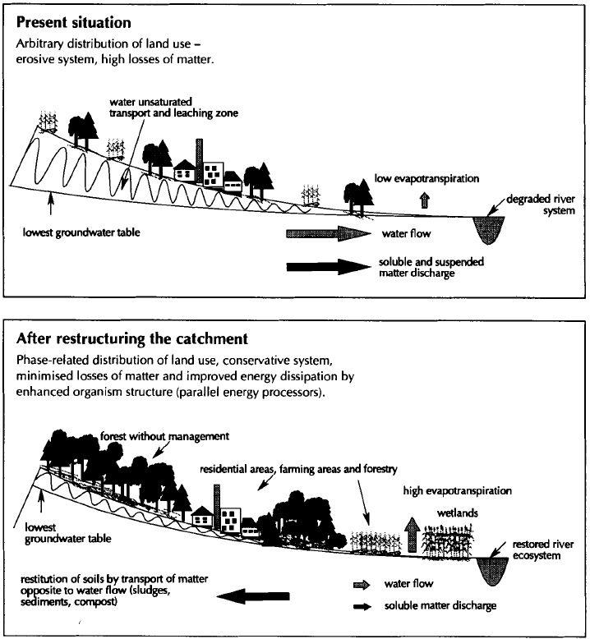
Figure 3. Influence of catchments with different landscape cover types on the transport of substances, water and nutrients (Source: Ripl and Hildmann 2002).

Priorities in relation to the protection of endangered habitats and populations
Given the results achieved, the definition of suitable biotopes is a "secondary", but no less important, objective. Indeed, the key issue has turned out to be the maintenance of water in the wetland ecosystem of Velika Tišina and Odmut. Local habitats will naturally evolve and adapt to the condition that will be achieved through revegetation. That is, only after the main objective of returning, but especially maintaining, water in the wetland has been achieved.
Despite this, it is possible to characterise the habitats that, in experts' experience, arise in similar ecosystems and bring high biodiversity potential. The wetland ecosystem of the Velika Tišina and Odmut exhibits characteristics that are very similar to shallow eutrophic ponds, pools and oxbow lakes, not only in the Czech Republic. Therefore, experts felt free to use the categorization of habitats that is described primarily for the Czech Republic. First of all, as already indicated in Chapter 2, it is necessary to create conditions for maintaining a diverse ecotone zone (Figure 1). This will create conditions for the subsequent development and maintenance of new habitats. For example:
- Macrophyte vegetation of naturally eutrophic and mesotrophic still waters
- Macrophyte vegetation of shallow still waters
- Macrophyte vegetation of oligotrophic lakes and pools
- Reed beds of eutrophic still waters
- Eutrophic vegetation of muddy substrata
- Mesotrophic vegetation of muddy substrata
- Tall-sedge beds
- Vegetation of annual hygrophilous herbs
- Vegetation of exposed fish pond bottoms
- Vegetation of exposed bottoms in warm areas
- Wet or inundated meadows
Controlled fluctuation of water levels will allow all of the above habitats to develop. The key to increasing biodiversity potential is the gradual development, but also the retreat of habitats over the season as the water level gradually falls or rises. Thus, the potential for biodiversity enhancement more in terms of seasonality is visible = the alternation of different conditions optimal for different communities, rather than at specific times of the year.
From this point of view, it is recommended initiating, before, during and after revitalisation, at least basic monitoring of habitat development (see more in chapter 5). The aim is to have an overview not only of development and diversity, but at least the subsequent definition of threats and management of habitats.
The aforementioned categorisation of biotopes is primarily based on the typical plant communities of the biotope and their requirements for environmental conditions. These biotopes, of course, subsequently create the conditions for the development of rich animal biocenosis.

Priorities in relation to the identification of wetland functions with an assessment of current status and trends
In this chapter, the function of wetlands mainly in a climatic context has been assessed (in details Annex 4). Wetlands are ecosystems in which vegetation adapted to flooding develops. They are characterised by the presence of water either reaching the soil surface or at least the root zone. Wetlands soil has special characteristics and differs from other soils, e.g. low oxygen content. High primary production is a source of energy for the next stages of the food chain and for the accumulation of organic matter. Wetland plants retain and bind nutrients, allowing them to be recycled and reducing the trophic level of water. Wetlands are important landscape features that have an irreplaceable role in the hydrological cycle. They are able to retain water, attenuate flood waves in the lower parts of the catchment. Thanks to their functions, wetlands are also beginning to appear in the legislation of various countries. On the other hand, they are one of the most devastated ecosystems on Earth. Wetlands are subject to extensive drainage in order to provide new areas for the expansion of agricultural land and construction. Degradation of wetlands leads not only to loss of biodiversity, a reduced role in the water cycle, nutrients and energy flows, but also to loss of other ecosystem services.
One of the potentially most important but still under-appreciated services provided by wetlands is their role in climate formation and energy flows. In relation to climate, wetlands can be seen as both a passive component exposed to global climate change or as an active component that influences climate indirectly through the production/sequestration of greenhouse gases. Wetlands primarily affect the local climate directly. Solar energy is bound in wetlands and in vegetation supplied with water through plants and water vapour. During the day, they cool their surroundings by evaporation of water (evapotranspiration) and at night the sensible heat of water vapour is released. This balances out temperature and pressure differences over time and between locations, thereby moderating air velocity. Evapotranspiration converts many times more energy than photosynthesis. Water and plants are the main regulators of the flux of solar energy in the landscape and thus play an important role in the formation of climate. Aforementioned highlights the direct function of wetlands and the climatic effect of evapotranspiration.
The first part of the Annex 4 is devoted to the theoretical basis of the principles of solar energy distribution in the landscape, the question of why the landscape is drying up, and the relationship between land cover, solar energy distribution and climate. We also discuss why evapotranspiration is one of the most important cooling mechanisms in the landscape and how it is linked to wetlands.
The second part of the Annex 4 focuses on the actual assessment of the importance of wetlands in the drained agricultural landscape. Based on the analysis of Landsat satellite data, Tišina wetlands is presented as a cooling feature in the landscape and its changes since the mid-1980s are analysed. Based on the same data, changes in surface temperature in Tišina were analysed in the monthly time step March-September 2024. For a detailed temperature analysis of Tišina area in relation to different land cover types (crop-trees-bare soil), data were acquired at higher spatial resolution (15 cm) using a drone-borne thermographic camera.
The third part contains an assessment of meteorological data for the Tišina area, from 1960 to 2023. The question was whether, as in other places in the world, the intensity of incident solar radiation is increasing due to a decrease in cloud cover. This reduction in the greenhouse effect of water vapour, together with the loss of permanent vegetation well supplied with water, results in increasing temperatures, extremes, drying out and climate change.
The Tišina wetland, together with the Sava River and forests, is the coolest type of landscape cover in the wider model area. This is confirmed by a retrospective analysis of Landsat temperature data since the 1980s. Compared to the surrounding agricultural landscape, the temperature regime of the wetland is characterised by a low temperature amplitude (up to 10°C, i.e. small differences between minimum and maximum temperature). In the agricultural landscape, temperature amplitudes are more than 20°C. However, over the long-term monitoring horizon, there is a very noticeable increase in surface temperatures both in the surrounding landscape and in the reserve itself. Especially from 2022 onwards there is a significant shift towards extreme temperatures of the agricultural landscape (more than 50°C). It is the surrounding overheated landscape that reaches more than 50°C that is causing the wetland to dry out. Therefore, it is necessary to cool the surrounding landscape with permanent vegetation, to minimize bare overheated areas in the surroundings and to retain as much water as possible in Tišina during the spring months. The dependence of wetland functioning as an air conditioning device on sufficient water and preserved stands of wetland vegetation is well illustrated in the monthly assessment of Tišina in 2024. During the months of March and April, there was sufficient water in the wetland and surface temperatures were the lowest in the entire study area. As water levels drop, surface temperatures increase. Particularly in July, when the forests become the cooler land cover type and wetlands lose their cooling ability. Even higher rainfall totals in early July 2024 did not fill the wetland with sufficient water. The decline in cooling ability during this time is evidenced by an assessment of the ratio of latent heat of vaporization to sensible heat, using Bowen's ratio (assessed date July 13, 2024). The parts of the wetland without water were overheated due to very low evaporation, Velika Tišina was almost indistinguishable from the surrounding agricultural landscape. On the contrary, the important cooling function of the forest stands is evident. It is essential to note that higher evapotranspiration does not mean a loss of water, on the contrary. A decrease in evapotranspiration means an increase in temperature, sensible heat and drying of the landscape. In areas without vegetation there is lower evaporation, lower latent heat flux. For an evaporation rate of 100 mg.s⁻¹.m⁻², 240 W.m⁻² is consumed. If evaporation drops to, say, one-fifth, evapotranspiration consumes only 50 W.m⁻² and 190 W.m⁻² is bound into sensible heat instead of water vapour, which heats the surroundings. By managing water and vegetation in the landscape, we affect energy flows on the order of hundreds of W.m⁻². In addition, areas that are cooler serve as condensation points in the landscape, over which water that is not lost from the landscape is condensed back.
The increase in the temperature of the surrounding landscape can also be linked to the increasing intensity of incoming solar radiation and decreasing cloud cover and relative air humidity, especially in the last decade. The greenhouse effect of water vapour is decreasing, more energy is reaching the Earth's surface, and the surface is warming more. This has been confirmed by meteorological data evaluated for the Tišina area between 1960 and 2023 and corresponding to the analysis of the surface temperature of Tišina, based on Landsat satellite data analysis since 1986. Surface heating is more intense in the case of loss of permanent vegetation, sufficiently supplied with water, hence with a reduction in evaporation intensity and loss of condensation places in the landscape. For this reason, it is necessary to maintain permanent wetland vegetation in the reserve area with season-long water levels and permanent vegetation cover to cool the surrounding landscape.
A more detailed view of the temperature regime of the reserve is provided by the analysis of thermographic data taken by drone (see Figure 4). In this case, it is possible to analyse the temperature of individual crops, trees, wetland vegetation, etc. The landcover, i.e. also the crops grown on the soil blocks and the crop rotation practices, directly influence the distribution of solar radiation in the landscape and thus the climate and hydrological regime. It is important for agricultural landscapes to maintain continuous vegetation cover, especially in the summer months. Vegetation transpiration actively cools. A 1°C reduction in surface temperature by vegetation and evapotranspiration means a 5 W.m-2 reduction in heat flux. On 50 ha this is 2.5 MW of energy that is not released. Cooling this area would require 500 air conditioners, each with a cooling capacity of 5 kW. In June, crops can still be relatively "cool", which is reflected in lower temperature and higher latent heat flux and lower sensible heat values. As maturity increases, the surface temperature increases, often depending on the type of crop. In August, if the soil is bare, the sensible heat exceeds the latent heat, and the surface temperature often exceeds 50°C. An overheated agricultural landscape not only affects the climate but also the runoff of nutrients and water. Reducing the surface temperature of agricultural soils is important for reducing the intensity of mineralisation processes in the soil and thus the runoff of substances (nutrients).
The division of soil blocks by different crops may affect temperature and energy flows depending on the type of crop sown and its phenological phase. In June, when most crops are in the reproductive phase, the differences are not very noticeable. Especially if there is sufficient rainfall. As the crop matures, the temperature increases, the proportion of sensible heat increases, and the latent heat of vaporisation decreases. For the distribution of the soil block by different crops to have an effect in terms of the distribution of energy fluxes, it is advisable to rotate cereals, fodder crops, legumes or root crops. It is not very efficient to divide the soil block with crops with the same phenophase, i.e. growing crops that are harvested and maturing (almost) simultaneously. The key aspect is to maintain green vegetation on the soil block and to minimise periods when the soil is bare or covered with stubble. Increasing the proportion of energy tied up in evaporation can be achieved using undersowing, intercropping, and striving for a stand with a vertical structure.
Cooling of the surrounding landscape is therefore also a key aspect of retaining more water in the Tišina area.
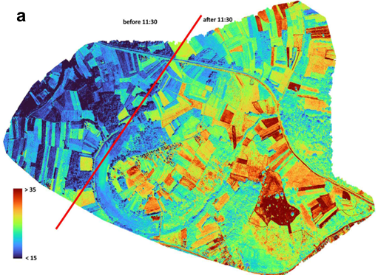 | 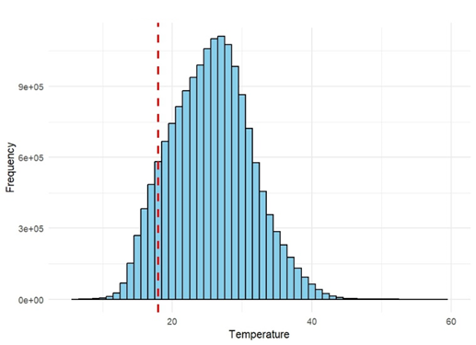
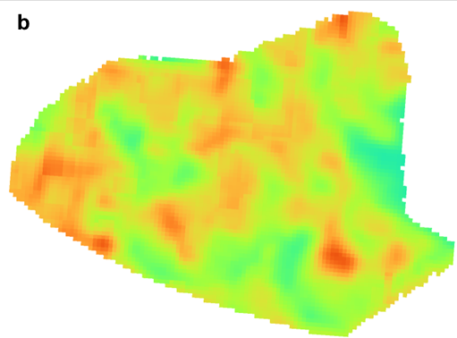 | 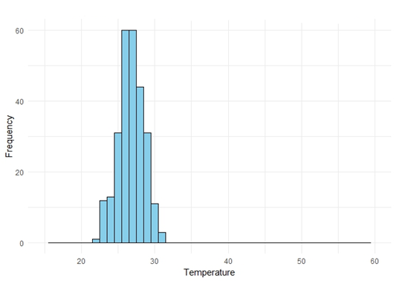
Figure 4. Thermal maps and temperature distributions obtained from a) drone and b) Landsat 8 satellite platform on September 22nd

Rapid assessment of ecosystem services
Ecosystem services are characterized as the ability of natural processes and components of an ecosystem to provide services to humans and other forms of life. Natural processes are described as a complex set of interactions between biotic and abiotic components of an ecosystem, supported by cyclical flows of energy and substances, i.e. biogeochemical cycles (De Groot 2002). The same author recommends a selection of several features of the complexity of ecosystem processes against which they can then be evaluated ecosystem services that result from them. He considers these basic functions to be:
- Regulatory (the ecosystem regulates basic processes and creates a life-support system by biogeochemical cycles and other processes such as energy transport to biomass, storage and conversion of minerals and energy in the food chain, mineralization of organic matter, regulation of climate, etc.)
- Habitat creation (the ecosystem creates space for plant life, reproduction and animals)
- Production (photosynthesis and autotrophic organisms convert energy, oxide, carbon dioxide, water and nutrients into hydrocarbon structures, resulting in services such as production of food, materials, energy resources, etc.)
- informational (providing human experience of the outdoors and provides spiritual enrichment, rest and recreation, knowledge and aesthetic values).
There are many ways to assess ecosystem functions and services. Some of the examples of ecosystem services approaches (Seják et al. 2010) are:

Complex methods
Banzhaf and Boyd (2005) produced an analysis of ecosystem services and a list of those used indicators, which they divided into five basic categories (biodiversity, biotic integrity, hydrogeomorphic assessment, habitat suitability for target species, and biophysical conditions). In this case ecosystem services include:
- air and water purification
- drought and flood mitigation
- creating and protecting soils and restoring their livelihoods
- detoxification and decomposition of waste
- pollination of agricultural crops and natural vegetation
- seed dispersal
- nutrient cycling and distribution
- pest control
- protection of river banks from erosion and waves
- protection from UV radiation
- contribution to climate stabilization
- mitigating weather extremes and their consequences
- providing aesthetic experiences, beauty and intellectual stimulation

Methods targeting a specific type of ecosystem
Other assessment methods vary according to the specific type of ecosystem they target (basic division into aquatic, wetland and terrestrial ecosystems).

Assessment of ecosystem functions by trophic structure and energy
Examples of these evaluations include:
- The energy analysis
- optimization of energy capture
- optimization of energy and substance reserves
- analysis of the trophic exchange network as an indicator of ecological functions
- trophic spectrum as an ecosystem indicator

Ecosystem function assessment by flux of substances
Examples of these evaluations include:
- Set of ecosystem-based indicators for landscape scale (relative equilibrium of the basin (for C and N).
- C and N stock dynamics - a key indicator of ecosystem functions
- Internal flows and cycles - reducing nutrient loss
- C/N ratio - an indicator of the susceptibility of soils to N leaching upon N atmospheric deposition
- Substance processes indicating the health of river ecosystems

Ecosystem functions in relation to climate
Examples of these evaluations include energy dissipation by evapotranspiration, temperature balancing
According to Ripl (2003), one of the most important ecosystem functions (services) is the dissipation of solar energy through evapotranspiration, during which energy from the sun is converted into latent heat of vaporization and thus prevents overheating of the Earth's surface. This is linked to the small water cycle, as sufficient water in the ecosystem is a key factor for the functioning of the so-called ecosystem dissipation unit. Water scarcity is manifested, among other things, by temperature fluctuations during the day and year.
This approach has been used to assess Tišina wetlands functions
Expanding human populations, and mainly their insatiable and unprecedented self-interested striving for the individual’s profits and material wealth, have led to half of the world's most important natural habitats being converted for other uses. As mature natural forests and wetlands are being removed and changed mainly into agricultural, urban, and infrastructural areas, basic ESs decrease, and the global climate change problem is exacerbated. Since the late 19th century, the destruction of natural ecosystems has been supported by the neoclassical welfare concept of economic value as unilateral anthropocentric marginal utility perceived by the human individual. Valuing ecosystem services (ES) unilaterally, as based only on benefits to individual humans, has led to systemic undervaluation and false value relations of their real importance, and to the fragmentation of landscapes. Therefore, it is highly important to understand how the monetary values of such ESs are derived.
The world's growing population, and in particular its increasing material demands and the purely material orientation of human individuals to their own benefit in developed economies, have brought about the last century - and especially in the period since the Second World War - dramatic pressures on transformations of the Earth's natural land cover. Humans are draining land, removing natural vegetation and generally do "land development" for their own benefit. Largely unwittingly they are significantly upsetting the delicate balance of the Earth's biosphere and accelerating processes now commonly referred to as global warming. The main pressures on the degradation of nature and its autotrophic ecosystems arise from the economic activities of humans and in market economies from their socially and ethically accepted and supported material orientation for their own benefit. Because people still value nature largely as a resource of their own economic benefits, it is becoming increasingly clear that the way to create a balance between the growing economic demands of people (including their growing demands for land) and the increasingly urgent the need to protect nature and its habitats that are being destroyed and constrained by humans life-giving ecosystems is in the development and introduction of monetary values of nature's ecological functions and services.
Ecosystems and their energy-material and information flows consist of basic conditions for the existence and development of life forms on Earth. The conclusions of the global project Millennium Ecosystem Assessment defined the so-called supporting, provisioning, regulating and cultural services of ecosystems. While ecosystem functions are most often associated with the characteristics and processes of ecosystems, the concept of ecosystem services is related to their direct or indirect benefits to human populations. However, the valuation of individual ecosystem services still has been largely subsumed under the traditional mechanistic, Cartesian, anthropocentric and subjectivist approach, which does not allow the interdependence of all ecosystem components, does not allow us to express that a living system is more than the sum of its parts. Such systemic assessments are only possible using ecosystem methods and approaches that view the ecosystem as a self-organising whole. For all these reasons, expert methods have begun to develop that are able to capture the intrinsic values of ecosystems.
One of the expert methods to estimate the value of ecosystem services is to express how much it would cost to provide the services through alternative, anthropogenic means. In that the biosphere is irreplaceable for human life and therefore its economic value most experts agree. However, it is well known that in economic practice, infinite quantities of services are often transformed into zero values because they are simply not valued in monetary terms.

Estimation of the value of the Tišina wetland ecosystem services
Estimation of the value of the Tišina wetland ecosystem services is based on our experts developed methods (Seják et al. 2018, Pokorný and Seják 2009, Seják et al. 2010). These methods are:
    - valuing biotopes by Biotope valuation method (Seják, Dejmal et al. 2003), hereafter BVM;
    - basic supporting and regulating ecosystem services (by Energy-water-vegetation method, hereafter EWVM) that show more completely the real importance of the natural environment in its diversity and maximal utilization of incoming solar energy.
The BVM is targeted at biodiversity and habitat protection. BVM is based on a score of habitats, where each habitat is assigned a score/point, and each point has assigned a financial value. Examples are urban development areas (0-2.4 points; 0-1 €/m²); arable land (11.2 points; 6 €/m²) and wetlands (33.5 points; 17 €/m²).
In the EWVM, the value of biotopes was combined with the cost of services that the biotope provides (acclimatising function, water retaining and purification function, oxygen production, carbon sequestration, nutrient retention). In other words, the price of ecosystem services is expressed in terms of the energy and commodity prices that are valid in everyday life.
Based on the EWVM, we made an order-of-magnitude estimate of the baseline set of annual ecosystem services of all biotopes in Tišina wetland reservation. The basic quantification is calculated for 1 ha and one year.
The following biotopes are in the territory of the Tišina reserve: wetland, water, broad-leaved forest, degraded broad-leaved forest, arable land. The information about habitats were provided by the project partner – ITI, d.o.o in as vector data in ESRI shapefile format.
For quantification, we consider the following input assumptions, derived from the production ecology, photosynthesis equation, Avogadro's law, and stoichiometry.
- 1ha of wetland/forest/arable land produces 5 t biomass / year
- 1ha of degraded forest produces 4 t biomass / year
- 1 ha evaporates 5 000 000 l / year (1m² evaporates 500 l of water/year) – wetland, forest
- 1 ha evaporates 2 000 000 l/year – arable land
- 1 ha evaporates 3000 000 l/year – degraded broad-leaved forest
- When 1t of biomass is produced, 1,06 t of oxygen is also produced (1 g biomass and 1,06 g of oxygen is produced by photosynthesis)
- 1t of oxygen is 716 000 l of oxygen (1 kg oxygen = 716 l of oxygen; Avogadro's law)
- To produce 1t of plant biomass 1.46t of carbon dioxide is needed (from the photosynthesis equation)
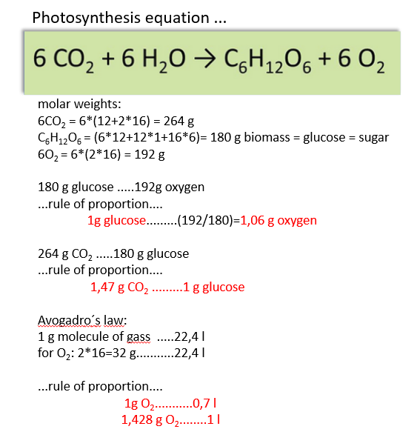
Figure 5. Ecosystem services of wetland – example of calculation.

The flood control service of the wetland
The flood control service of the wetland is based on the cost, which is looked at as the investment that has to be made to build a 1 ha reservoir. Using the example of costs in the Czech Republic, this is an amount of 40 000 €, which, converted to annual flood protection service (at a 5% discount), represents an amount of approx. 2 000 €

Nutrient retention
Retention of 1 tonne of alkalis compared to meliorated arable land = 1 000 kg x 2 € = 2 000 € per year

Biodiversity
Alluvial meadows are assessed by 46 points/m² [2], which is 460 000 points per 1 ha x 0,5 €/point = 230 000 €. At a 5% discount, it represents an annual service of biodiversity of approx. 11 500 € per year

Oxygen production
5 t biomass = 5,3 t oxygen = 3 794 800 l oxygen x 0,2 €/litre = 758 960 €/year

Air-conditioning service
5 000 000 litres of evaporated water per year from 1 ha x 1.4 kWh (0.7 kWh cooling, 0.7 kWh of warming) x 0,25 €/kWh = 1 750 000 €/year

Support of the short water cycle, water purification/distillation
Expressed as the amount of water that passes through the plant body of the vegetation, whereby the water is purified. Vaporation of 50 m3 per 1 ha means an annual service 5 000 000 x 0,2 € (cost of distilled water) = 1 000 000 €/year

Carbon sequestration
5 t biomass = 7,35 t CO₂ x 60€ (emission allowance price) = 441 €
Total service from 1 ha of wetland 3 524 901 €/year (352,4901 €/m²)

Ecosystem services of broad-leaved forest – example of calculation
For a deciduous forest ecosystem saturated with water, the estimations of services (estimated by replacement cost approach and biotope valuation method) were as follows:

Biodiversity
Hardwood forests of lowland rivers are valued according to the BVM at 66 points per 1 m2, which for 1 ha means 660,000 points x 1.17 € per point = 772 200 € of stock value (1.17 is an average national cost of recent restoration projects per one point increase, valid in 2018). With a 5% discount rate (to change the stock into a flow), this means annual services worth 38 600 €.

Estimation of forest oxygen production
5 t biomas = 5,3 t oxygen = 3 794 800 l oxygen x 0,2 €/litre = 758 960 €/year

Forest climatizing (air-conditioning) service
5000000 litres of evaporated water per year from 1 ha x 1.4 kWh (0.7 kWh cooling, 0.7 kWh of warming) x 0,25 €/kWh = 1 750 000 €/year

Support of the short water cycle, water purification/distillation
Expressed as the amount of water that passes through the plant body of the vegetation, whereby the water is purified. Vaporation of 50 m3 per 1 ha means an annual service 5 000 000 x 0,2 € (cost of distilled water) = 1 000 000 €/year

Carbon sequestration
5 t biomass = 7,35 t CO₂ x 60€ (emission allowance price) = 441 €
Total service from 1 ha of broad-leaved forest 3 548 001€/year (354,8001 €/m²)
The value of other biotopes – arable land, broad-leaved degraded forest, water bodies were calculated similarly, and the values of all biotopes are summarized in Table 1. As it was mentioned, the information about the biotopes in the reserve was retrieved from the vector data (shapefiles) provided by local experts. The value of biotopes was calculated only for the part of the biotope that lies within the reserve.
Table 1. Annual value of ecosystem services of biotopes in Tišina reservation.
Biotopes | Total area (m²) | Ecosystem services value €/year/m2 | Ecosystem services value €/year
Water/Vodene površine | 335 891 | 220 | 73 896 100
Wetland / Vlažna zona | 753 555 | 353 | 266 005 000
Broad leaved forest/šume | 217 159 | 355 | 77 091 600
Broad-leaved forest degraded/Degradirane šume | 231 635 | 166 | 38 451 400
Drained arable land/isušene poljoprivredne površine | 663 320 | 111 | 73 628 500
Urban areas / urbano površine | 60 189,5 | 0 | 0
Total |  |  | 529 072 600

Wetlands and forests are among the most valuable biotopes, providing services (climate-forming, water-retaining, etc.) of the highest value compared to anthropogenic or agricultural areas. The total value of the wetland biotope (water+wetland) in the Tišina reserve alone is 340 million €/year, with broad-leaved forests also having a significant value (77 million €/year). Adding up the value of all biotopes, the value of the ecosystem services of the reserve is estimated at almost €530 million/year.

Establish local restoration priorities in relation to the river basin’s management plan and goals
The Tišina PA restoration plan seeks to link closely to the broader objectives set out in the Sava River Basin Plan in the Republika Srpska. The Tišina wetlands, as an important part of the river systems of the Bosna and Sava, serve not only as a critical centre of biodiversity, but also as an integral part of the hydrological network of the region. The restoration of the Tišina seeks to address ecological and hydrological issues while also reinforcing the objectives of sustainable water management and ecosystem protection set out in the river basin management plan.
The river basin plan emphasises the achievement of good ecological and chemical status of water bodies, with priority given to hydrological restoration and pollution control. For the Tišina, this means measures such as removing sediment deposits, increasing water retention capacity and reconnecting wetlands with surrounding water systems such as the Žandrak channel. These measures are intended to counteract the negative effects of hydromorphological changes, such as the disturbed natural runoff regime and sediment transport, which are identified as primary pressures in the river basin management plan.
As stated in the river basin management plan, the protection of ecosystems directly dependent on water resources is a key strategic objective. Proposed Tišina restoration plan includes measures such as habitat enhancement, invasive species management, and implementation of adaptive land use practices. The goal of these efforts is to preserve critical habitat for species listed under national and international conservation guidelines and to ensure that Tišina continues to support a diverse array of plant and animal life.
The River Basin Plan emphasises the need for integrated management of land and water resources to mitigate diffuse pollution and adapt to climate variability. The measures proposed in Tišina, such as optimising land cover and introducing sustainable land use changes, contribute directly to this objective. By prioritising practices such as cover crops and riparian restoration, the plan seeks to increase the landscape's capacity to retain water, reduce evapotranspiration and improve the local microclimate.
The restoration of the Tišina is in line with the basic and complementary measures set out in the river basin management plan. These include:
  - Core measures: Controlling water abstractions, reducing diffuse pollution from agriculture and strengthening water quality monitoring.
  - Complementary measures: Involving stakeholders in the design and implementation of restoration projects, carrying out detailed ecological and hydrological studies and using innovative technologies such as drone monitoring and automatic water level sensors.

Wetland restoration operational objectives

Conservation objectives
After a careful study of all the evidence gathered and defining the boundary conditions resulting from the list of parameters investigated, as shown in Box 2, a basic chronology of the envisaged measures was emerged, expected to contribute in the future to:
- Provide alternative and safe water sources for continuous inflow to the Tišina wetland system.
- Maintain the water level during the vegetation season at a higher level than at present.
- Create conditions for, at least maintaining, optimally increasing biodiversity in the protected area.
The above-mentioned points are intended to lead to the achievement of the set objectives of the territory's restoration. In this case, they are defined as follows (see Box 3):
Box 3. Goals of the Tišina protected area restoration
- Preserving a mosaic of different habitats
- Controlling community composition (plant and animal species)
- Allowing water fluctuation to rule biodiversity patterns

Final ecological status
Based on the findings at the site, it is necessary to consider a balanced hydric regime of the landscape as the target condition. In this case, the ecosystem of Velika Tišina and Odmut will not be subjected to strong annual water fluctuations/losses. Such a target is essential for the achievement of other sub-objectives and is also in line with the opinion of local institutions. If at least the basic technical measures can be implemented in the first phase of the revitalisation, such a target is in our view achievable. If the measures are successful, i.e. if the loss of water from the system is halted, another important objective can also be expected - the increase and stabilisation of species diversity.

Areas of periodic flooding
To delineate the areas which should undergo the flooding the detailed study of the terrain morphology was used (see Annex 3. Geodetic survey). The bottom of Mala Tišina, Velika Tišina and Odmut was then modelled using ArcGIS pro and 3D models of the wetlands were then created using AutoCAD 2025. This allowed experts to predict the volumes of water that are present in the wetland system at different water levels (recalculated to absolute elevation).

Mala Tišina
Mala Tišina is now a practically extinct wetland. Only occasionally the water level rises above the ground level. In 2024, the recorded water level was 82.5 m above sea level, which corresponded to a very small, flooded area of a few tens of square metres. The following Figure 6 shows the morphology of this wetland. In the reservoir volume analysis, we focused only on the elevation of 82.5 (the current minimum of the reservoir) to 83.5 m.a.s.l.
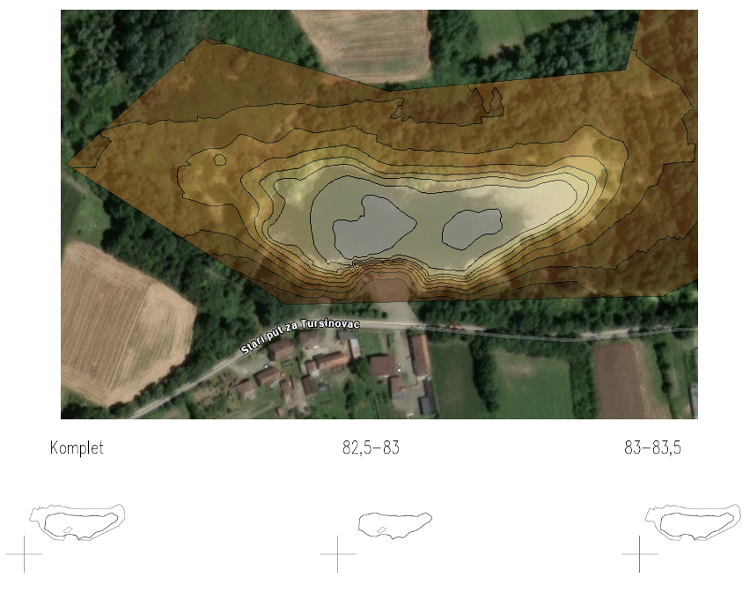
Figure 6. Morphology of Mala Tišina

The analysis shows that when flooded to 83.5, the estimated maximum potential at hydrological maximum, the volume of Mala Tišina is 6,125 m³. The length of the bank reaches 664 m with a flooded area of 1.8 ha. The total flooded area is therefore shown at Figure 6 in the bottom right contour.
Table 2. Analysis of the Mala Tišina wetland morphology
Elevation range (m.a.s.l.) | Water surface (m²) | Volume of the layer (m³) | Cumulative volume (m³) | Edge length (m)
82,5-83 | 9 898 | 1 905 | 1 905 | 483
83-83,5 | 18 367 | 4 220 | 6 125 | 664

Velika Tišina
Velika Tišina is currently a wetland with significant water fluctuations. Its morphology is defined by several factors, including the historical shaping by the river, the various infilling of river sediments and deposition of clay layers and, last but not least, significant grounding due to the deposition of organic material (overgrowth of wetland vegetation). Human interventions, such as the digging of a longitudinal channel in the western bank, have also contributed to the morphology in recent years. An analysis of the bed morphology is presented in Figure 7. This analysis allowed us to first determine the volume of water in the wetland when filled to defined water surface elevations. However, it also allowed experts to determine what the lengths of the shorelines (the so-called ecotones) are at these water level elevations, which are intended to be retained as a major determinant of high biodiversity in the restoration of the area.

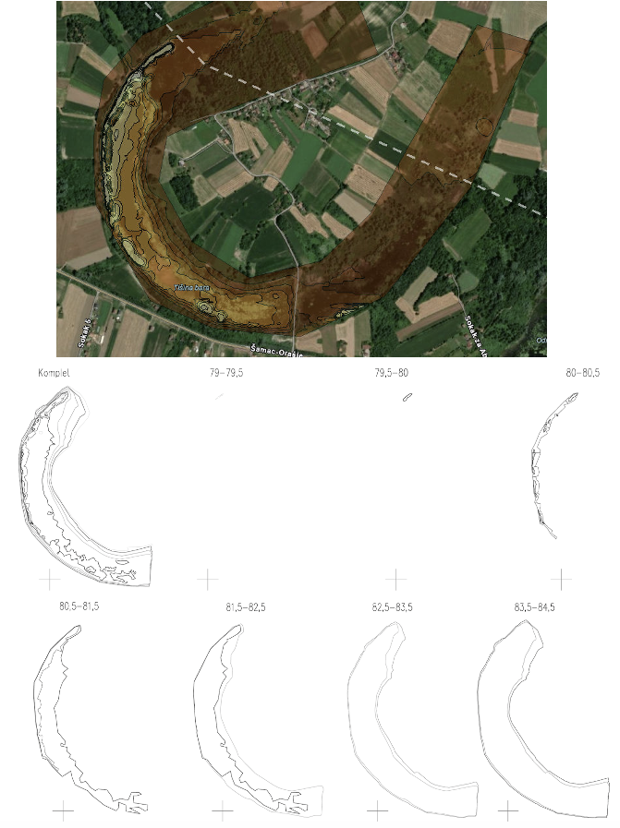
Figure 7. Morphology of Velika Tišina
All these data are presented in Table 3. It shows that the lowest depth is 79 m above sea level. The level then normally reaches a level of 82.5 m.a.s.l. (such as during the spring of 2024), at which the accumulated volume is 168 thousand m³ with a surface area of 15.5 ha. At the hydrological maximum, the level can then reach 83.5 m, when the accumulated volume is 338 thousand m3 with a surface area of 18.4 ha. However, from the analysis of shoreline length, the most important level is 81.5 m.a.s.l., which provides by far the longest ecotone. Therefore, this water level was determined as the minimum wetland elevation below which water should not be allowed to fall at all.
Table 3. Analysis of the Velika Tišina wetland morphology
Elevation range (m.a.s.l.) | Water surface (m²) | Volume of the layer (m³) | Cumulative volume (m³) | Edge length (m)
79 - 79,5 | 139 | 25 | 25 | 97
79,5-80 | 502 | 157 | 182 | 118
80-80,5 | 16 061 | 4 009 | 4 191 | 1 743
80,5-81,5 | 87 468 | 42 456 | 46 647 | 3 051
81,5-82,5 | 154 868 | 121 519 | 168 166 | 2 703
82,5-83,5 | 183 571 | 169 406 | 337 572 | 2 761
83,5-84,5 | 210 859 | 200 666 | 538 238 | 2 820

Odmut
Odmut is a wetland that probably does not have a natural origin but was historically created in places where materials were mined for the construction of flood defences. Its hydrogeological conditions are then the most complex of all wetlands and the research carried out assumes that the water level fluctuates most dynamically here.
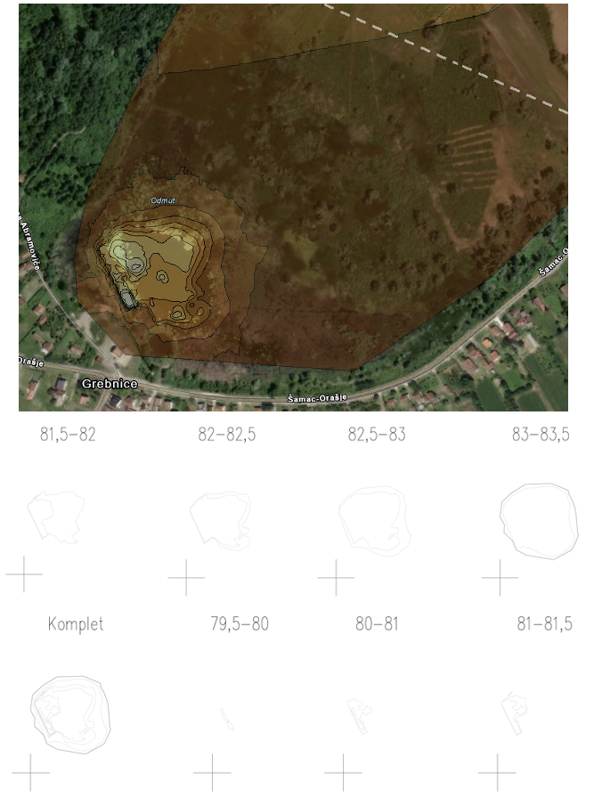
Figure 8. Morphology of Odmut

The lowest measured level is 79.5 m, with a surface area of approximately 500 m² and a volume of only 90 m³. In standard years, the level can be expected to reach 82.5 m.a.s.l., at which the surface area will be 2 ha and the accumulated volume 14.6 thousand m3. In a hydrologically rich year it is possible to reach up to 83.5 m.a.s.l., at which point at least 3.5 ha will be flooded. As we could not carry out a complete ground survey due to the undermined area, we cannot therefore correctly estimate the complete flooding rate. According to remote sensing images, the area of flooding may reach up to 40 ha.
Table 4. Analysis of the Odmut wetland morphology
Elevation range (m.a.s.l.) | Water surface (m²) | Volume of the layer (m³) | Cummulative volume (m³) | Edge length (m)
79,5-80 | 449 | 90 | 90 | 159
80-81 | 2 389 | 1 303 | 1 393 | 336
81-81,5 | 3 996 | 1 557 | 2 950 | 351
81,5-82 | 15 400 | 2 934 | 5 884 | 575
82-82,5 | 20 029 | 8 695 | 14 579 | 652
82,5-83 | 28 851 | 12 068 | 26 647 | 637
83-83,5 | 35 163 | 15 597 | 42 244 | 684

The following Table 5 summarizes the basic findings of defined water level fluctuations in all wetlands. These analysis results are then used as the basis for the proposed measures summarised in Chapter 4.
Table 5. Basic information about water fluctuation in wetlands
Water body | Minimum water level (m.a.s.l.) | Maximum water level (m.a.s.l.) | Volume on minimum level (m³) | Volume on maximum level (m³) | Litoral zone length on minimum level (m) | Litoral zone length on maximum level (m)
Mala Tišina | 82,5 | 83,5 | 0 | 6 125 | 0 | 664
Velika Tišina | 81,5 | 83,5 | 46 647 | 337 572 | 3 051 | 2 761
Odmut | 80 | 83,5 | 90 | 42 244 | 159 | 684

Proposal of zonation
The proposed zonation of the Tišina protected area is designed to balance ecological conservation with sustainable human activity, ensuring the protection of key habitats while allowing controlled activities in designated areas. The zonation strategy adopts a tiered approach based on hydrological and ecological criteria, with boundaries informed by water levels and surrounding land use. Proposed zonation is shown on Figure 9.

Zone 1 (Core zone)
The core zone is delineated by the lowest observed water level, representing the most ecologically sensitive area within the wetlands. This zone encompasses critical habitats for aquatic and semi-aquatic species, including breeding and feeding grounds for fish, amphibians, and birds. Human activities in this zone are strictly limited to avoid disturbance, with specific restrictions on baiting and fishing. These measures aim to preserve the natural dynamics of the ecosystem and support biodiversity conservation. Regular monitoring of water levels and habitat health will guide adaptive management in this zone.

Zone 2 (Secondary zone)
The secondary zone extends from the boundary of the core zone up to a five-meter perimeter beyond the highest water level recorded. This area allows for moderate human activities under controlled conditions. Fishing and grazing are permitted in this zone, providing sustainable use opportunities for local communities. However, activities such as plowing or the establishment of agricultural fields are prohibited to prevent habitat degradation and maintain soil and water quality. Management of this zone focuses on maintaining its role as a transitional buffer that supports both ecological functions and limited resource use.

Zone 3 (Tertiary zone)
The tertiary zone serves as a protective buffer surrounding the secondary zone, extending up to 200 meters beyond its boundaries. This area includes agricultural and other human-dominated landscapes, but its use must consider the ecological sensitivity of the protected area. Specific guidelines for land management apply, including the regulation of pesticide and fertilizer use to minimize runoff and contamination of the wetland. Activities in the buffer zone are designed to mitigate external pressures on the protected area, reducing the impact of human activities on the core and secondary zones.

Zone 4 (Buffer zone)
The buffer zone is the remaining area of the protected area that does not fall within one of the previously designated zones, but due to its location in the PA, precise management must be considered.
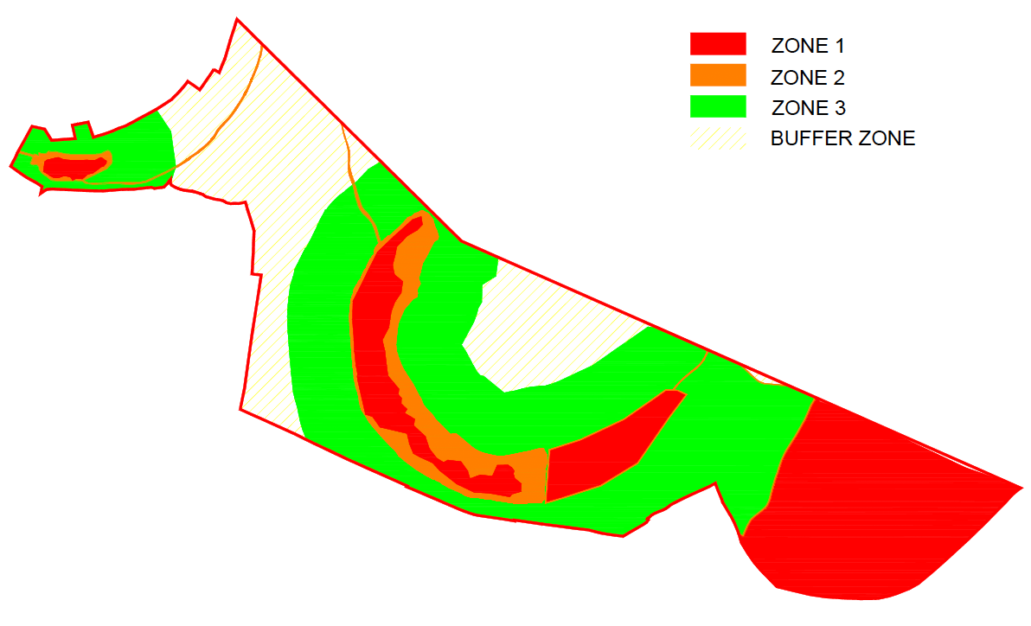
Figure 9. Zonation of the PA Tišina

Proposed restoration plan
This Chapter describes the specific measures that will be part of the restoration of the area. The plan outlines these measures in sufficient detail to enable the preparation of detailed design documents for their implementation in subsequent steps. The preparation of these measures has drawn not only on the evidence presented in previous chapters or detailed in earlier project outputs but also on considerations of the requirements and impacts on various stakeholders, including local communities, landowners, environmental NGOs, government agencies, and businesses operating in the area. Through this inclusive process, experts strive to ensure that each intervention is socially acceptable, ecologically beneficial, and contributes effectively to the overall goals of restoring the rare nature in Tišina PA.

Restoration measures
Here we present a proposal for the individual steps of this restoration. The measures are listed in Box 4.
Box 4. List of proposed measures.
- Removal of sediments in water bodies
- Building barriers and damns in Mala and Velika Tišina
- Building additional water source for wetland system
- Clearing of Žandrak
- Introducing specific management rules
- Optimizing land cover
- Changing land use in protected area
These measures are ordered according to the time of their implementation but also according to their effect.
Table 6. Categorization of proposed measures
Speed of implementation | Effect of the measures
Fast (within 12 months) = Measure 1, 2,3,4, | Short-term (up to 12 months) = Measure 2,3
Medium (12 - 24 months) | Medium-term (12 - 36 months) = Measure 4,5
Long (more is 24 months) = Measure 5,6,7 | Long-term (more than 36 months) = Measure 1,5,6,7

Removal of sediments in water bodies
An assessment of the volume and quality of sediment present in the wetland system was completed as part of the project (see Annex 5). Based on this assessment, it was proposed that sediment would be removed only in certain parts of the system:
- Mala Tišina
- Žandrak channel
- Parts of Velika Tišina
The areas proposed for the removal of sediments are indicated in Figure 10.
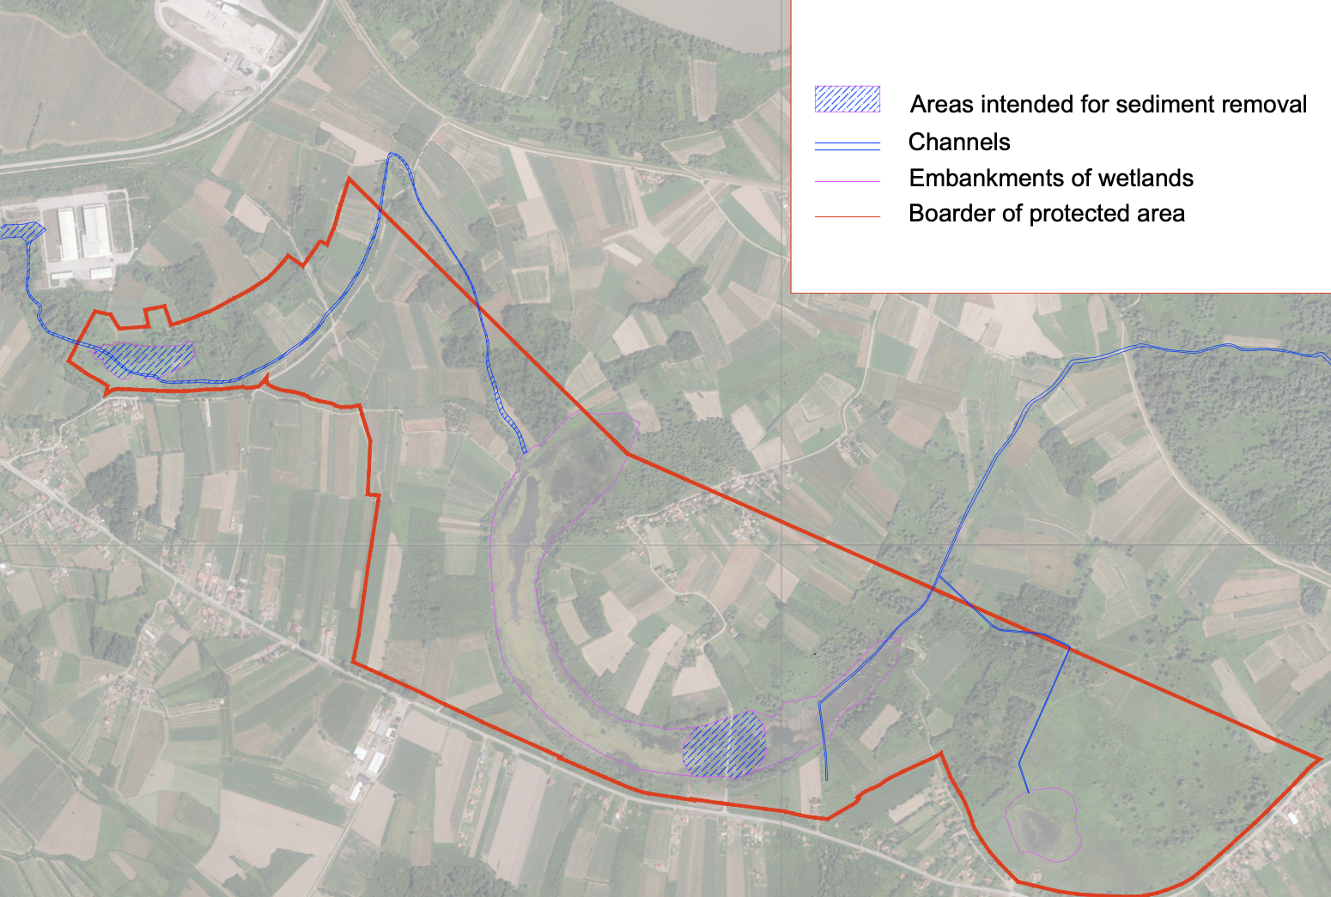
1
2
3
Figure 10. Locations of the planned sediment removal

Mala Tišina
Mala Tišina, together with Odmut, is affected the most with the sediment deposits. The problem with this former wetland is that it is a buffer zone on a tributary of the Žandrak, which has probably been gradually silted up by sediment from the river for decades. At the same time, there is a noticeable problem with the disposal of various excavated soils and construction waste in this area (see Figure 11).
In order to restore the function of the wetland, three basic steps are needed in Mala Tišina. The first is the removal of excess sediment (measure 1), followed by the provision of an alternative water source (measure 3) and the construction of a dam at the outlet with a regulated outlet structure. For the restoration of the Mala Tišina, the measures should be implemented in the following order.
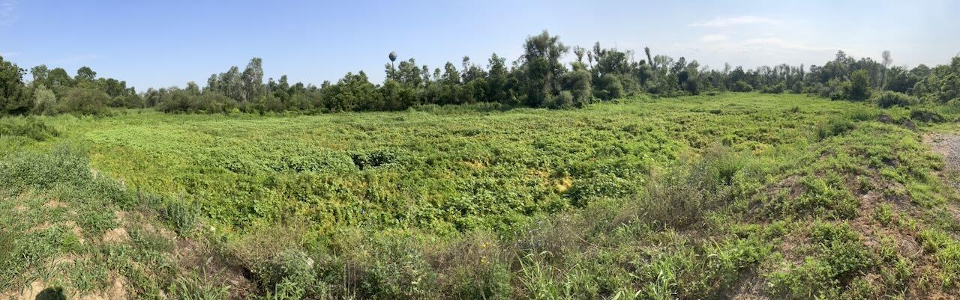
Figure 11. Actual status of Mala Tišina wetland (the bottom is fully covered with sediments and parts are filled with construction wastes, water appears only on a small part of the bottom during hydrological maximum)
The following Figure 12 shows the area concerned by the implementation of the sediment removal. The target bed elevation is to reach an elevation of 82.5 and this is over the entire 0.99 ha marked area. At the average sediment depth, this then represents 4950 m³ of sediment that will need to be disposed of. Given the proven quality of the sediment (see Annex 5), it could be deposited on agricultural land in the vicinity. Using a 5 cm layer, the area required for sediment distribution will total approximately 10 ha.
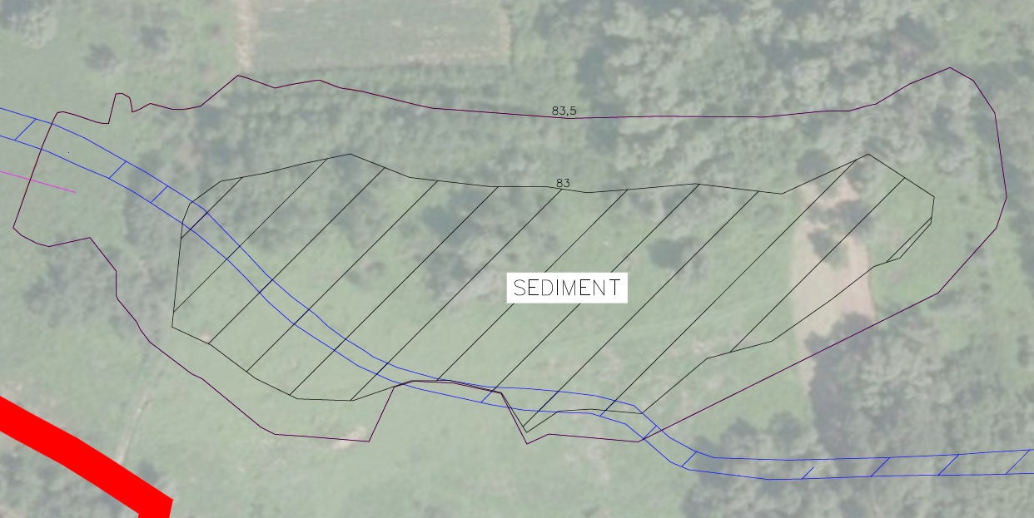
Figure 12. Area of sediment removal in Mala Tišina. Final elevation of the bottom should be 82,5 m.a.s.l.

Žandrak channel
At present, the entire Žandrak channel is covered with a layer of waste (possible alluvium from the 2014 floods), sediment and remnants of vegetation, which has practically overgrown the dry riverbed. The Figure shows a portion of the channel that is dry, overgrown with vegetation and full of debris. Cleaning up the Žandrak is a separate action (Action 4). However, sediment removal is also part of this measure. With a total considered length of the channel to be cleaned of 1 000 metres before the inflow to Mala Tišina and a further 1 800 metres between Mala and Velika Tišina, a total of 1 680 m³ of sediment must be removed at an average removal rate of 0.6 m3 of sediment per metre of channel (0.3 m of sediment removal in an average width of 2 m is calculated). If the channel is cleared of waste and biological material beforehand, then disposal on agricultural land can also be considered. In this case, when deposited in a layer of 5 cm, the sediment will be spread over 3,4 ha.
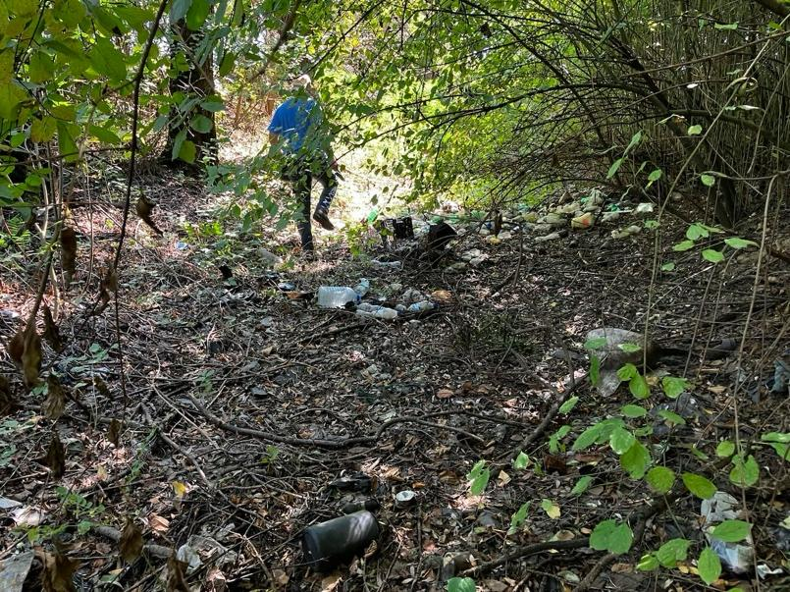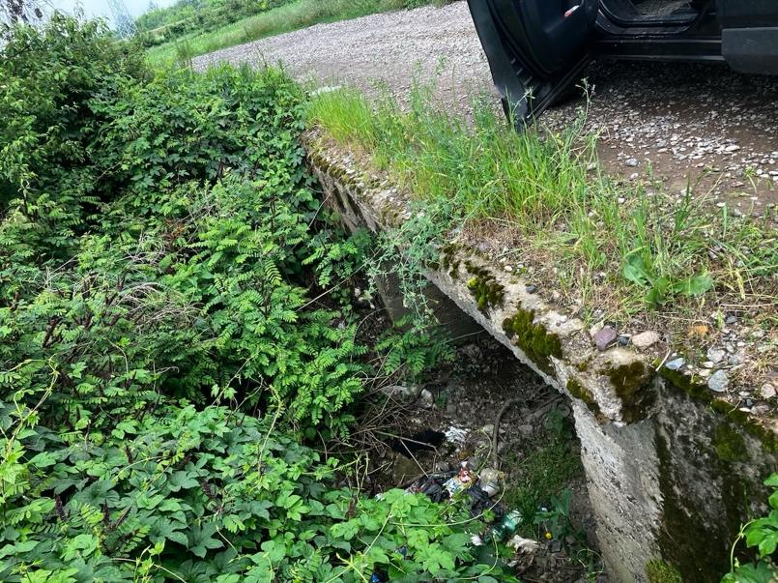
Figure 13. Actual status of the Žandrak channel at most parts of the Tišina PA.

Parts of Velika Tišina
As mentioned earlier in the document, it is ecologically important that wetland systems have dynamically changing conditions throughout the year. This may mean, for example, that water levels fluctuate throughout the year. Another important element that defines the richness of ecosystems is the amount of edge zones (mosaicism of the area). The transition between water and land, known as the ecotone, is important for animals associated with wetland habitats. With a view to preserving as much of the ecotone as possible in Velika Tišina experts propose that the morphology of the bottom and banks be left as it is today, as the bottom is sufficiently morphologically rich due to natural and human intervention (see chapter 3.3.1).
Experts are proposing to build a new regulation object within Measure 2, which will control the outflow of water from Velika Tišina; it will nevertheless be necessary to carry out partial sediment removal in this wetland. The location of the area is shown in Figure 10. At this location, we propose to remove only the amount of material that will be necessary for the movement of machinery during the repair of the dam and the construction of the outlet object. With an assumed average sediment layer of 0.5 m, this will amount to 14 500 m³ of sediment over an area of 2.9 ha. Again, it will be possible to spread it on the surrounding agricultural land. The total area required at a layer of 5 cm is 29 ha.

Building barriers and dams in Mala and Velika Tišina
One of the essential elements of the entire restoration of the area is to build a system of dams that will provide water regulation throughout the system. Specifically, experts propose to build 3 separate dams:
  - Regulation dam for Mala Tišina
  - Regulation dam for Velika Tišina
  - Regulation dam in the channel to Odmut
The proposed location of the levees is shown on Figure 14.
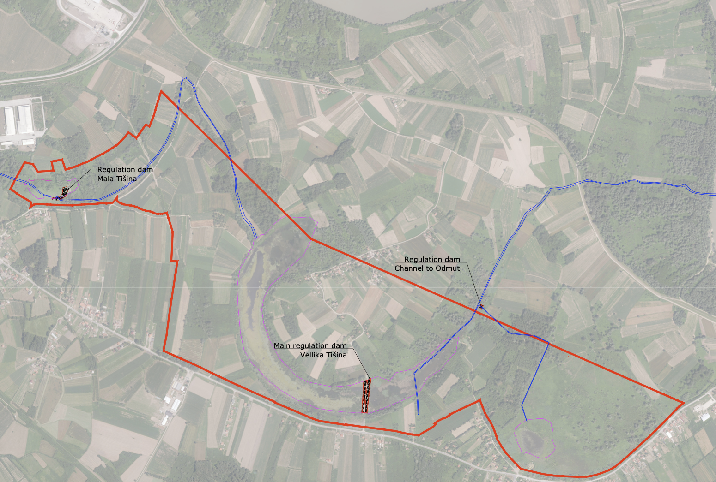
Figure 14. Situation drawing of the location of the newly proposed dams

Regulation dam for Mala Tišina
Currently, the Mala Tišina is in such a state that it is only fed by groundwater and only at times of hydrological maximum (winter and spring). In such situations, the water level reaches 82.5 m above sea level in a few spots. In order for Mala Tišina to continue to function as a wetland system in the future, it is necessary to artificially raise the water level in two gradual steps. The first is to provide an alternative water source (see Measure 3). The second is to ensure that the water remains in the wetland. This will be achieved by building a levee at the points of outflow into the Žandrak channel. This dam will have a regulated outlet object (see an example in Figure 15). This will ensure a minimum residual flow in the Žandrak (2 l/s) and maintain the maximum water level at 83.5 m above sea level. A safety spillway will also be designed in the crown of the dam to ensure that higher flows (e.g. flood events) can be accommodated. In case that water level reaches the maximum at 83,5 m.a.s.l. the whole wetland will hold up to 6125 m³ of water. The embankment should be fortified with loose coarse aggregate similar to that shown below to protect the earthen embankment body.
The regulation object can be designed in two versions. The first is a conventional manual design, which will include a manually adjustable gate that will need to be adjusted by the operator to maintain a specific level or desired flow in the Žandrak channel. The second is an automatically operated gate valve that will communicate with the level probe and flow meter at the outlet and will regulate the level and flow automatically. The second option is more appropriate with respect to wetland restoration requirements.
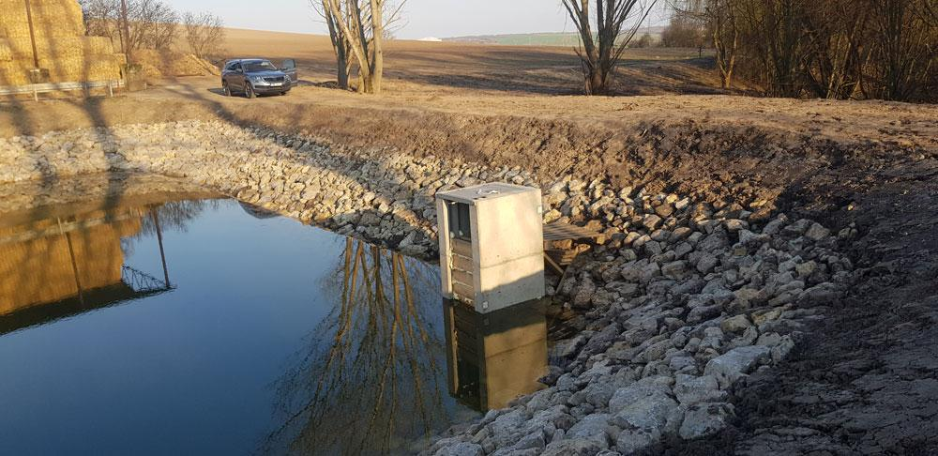
Figure 15. Example of regulation object proposed for the levee in Mala Tišina (Source: Prefa Brno)

Regulation dam for Velika Tišina
This is one of the most important elements of the overall restoration of the wetland system. Velika Tišina is largely affected by fluctuations in the water table, which allows it to rise at times of hydrological maximum. As the groundwater level begins to drop after the hydrological maximum, the Tišina also begins to experience a gradual loss of water through several places that could be described as sinks. In order to prevent water loss through these sinks, we need to provide a controllable outflow from Tišina. Therefore, experts propose to build a control structure and a new dam. Specifically, expert are considering using the existing road body that leads to the village of Tursinovac. This road is made in an embankment and practically forms a levee. Therefore, if an assessment by a structural engineer confirms the suitability of this structure as a dyke, then the existing culverts under the road can only be rebuilt and connected to a new outlet structure similar to the one in Mala Tišina. This would ensure that the maximum water level of 83.5 m.a.s.l. is reached and maintained, with outflow only in the event of a higher level being reached. However, this construction intervention will require several incremental steps:
- bottom stripping on both sides of the road (sediment removal, see previous Measure 1).
- Assessment of the impermeability of the embankment and possible addition of waterproofing (EPDM membrane or bentonite clay).
- Construction of a stone protection embankment on the embankment
- Rehabilitation of culverts under the road
- Construction of a new outlet structure with a control device on the west side of the road
Similarly to the Mala Tišina, the control device can be operated manually or automatically. Automatic operation is the preferred method. If the level of 83,5 m.a.s.l. were reached, up to 337,5 thousand m³ of water would be stored in the entire western part of Velika Tišina, which, even with the specified losses by evaporation or seepage, would be sufficient for the entire growing season to prevent unintentional drying up.

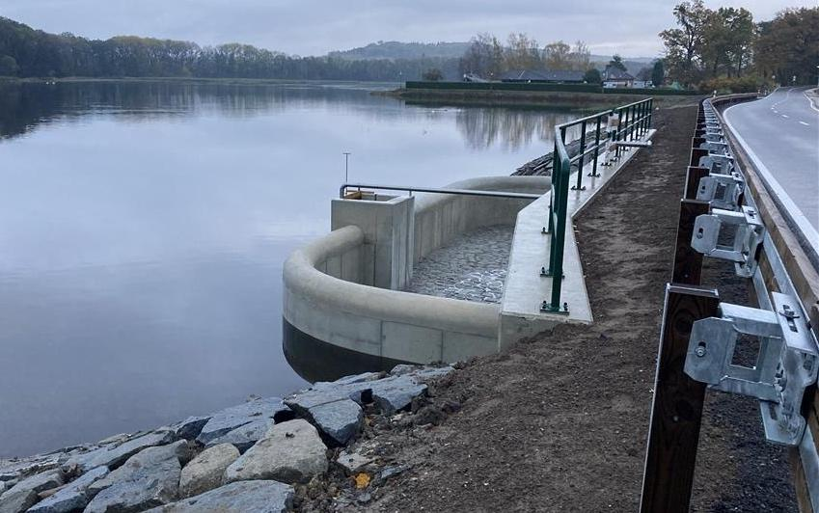
Figure 16. Possible solution of the dam at Velika Tišina - reconstruction of the paved road embankment to Tursinovac. This specific case shows a possible solution for regulation object and safety overspill build at the dam of the fish pond (Source: Opočno.cz)

Regulation dam in the channel to Odmut
Odmut is a hydrologically separate system from the Mala and Velika Tišina systems. Due to the probable absence of a clay layer in part of the bottom, Odmut is strongly influenced by the rise and fall of the groundwater level and thus in the case of a hydrological minimum it may threaten the rest of the wetland system due to water infiltration. It is therefore recommended that the channel connecting Žandrak to Odmut be closed. Here it is the simplest solution, which considers damming the channel that connects Žandrak with Odmut. Here, a levee with a control structure will be built, which will work on the principle of a one-way valve that will allow water to flow out of Odmut but will not allow it to fill from Žandrak.

Building additional water source for wetland system
In Chapter 3.3.1 experts described the actual fluctuation of the water in the whole system of Tišina and its reasons. The defined minimum and maximum levels of water in individual water bodies became the basis for calculating the required volume of water that would need to be subsidized into the system (see chapter 3.3.1). The estimations indicate that the volume required to saturate the total seasonal water loss from the area is 1013 m³/day. This is the volume which it is necessary to keep in the system, so it does not face the risk of the collapse. One of the solutions is Measure 2, which will in fact significantly help to decrease the water loss by infiltration or outflow. However, at the same time this assumption is based on the expectation that there will be sufficient water for recharge of the system in the spring season (the hydraulic maximum period).
It is therefore absolutely necessary to subsidise the wetland ecosystem with water gradually in the spring to autumn season with the peak during dry summer. On reflection, therefore, experts propose to build a system of two wells that will supply Mala and Velika Tišina with water from a shallow aquifer that is linked to water from the Bosna and Sava rivers.

Well for Velika Tišina
The overall strategy considers three water levels for Velika Tišina: a minimum level of 81.5 m above sea level, which should not be breached to prevent ecosystem harm; a naturally replenished level of 82.5 m, typically reached during spring, as confirmed in the spring 2024; and a potentially elevated level of 83.5 m, achievable by controlling outflows through a new dam (Measure 2), though it remains uncertain whether natural conditions could sustain this level. If the water naturally rises to 83.5 m, no additional supplementation would be necessary throughout the season, as the observed loss rate of 11.7 l/s (1013 m³/day) would only cause a drop to the minimum level of 81.5 m after 287 days—by which time, winter hydrological peaks and reduced evapotranspiration would likely replenish the system. Should levels peak only at 82.5 m, some pumping would be needed, though not the full 11.7 l/s; a partial supplementation of 5.9 l/s would sustain 81.5 m for 240 days, again lasting into winter. With evapotranspiration contributing to 84% of system loss, estimated at around 5.5 mm/day within vegetation season, and the remainder being seepage, this suggests that a reduced pumping rate could suffice. Therefore, experts recommend keeping pumping volume to one-third of the loss, or approximately 3.9 l/s, which would maintain the desired level of 81.5 m from April to the end of September (see the modelling of the water loss on Figure 17).

Figure 17. Hydrological regime of the Velika Tišina in different scenarios

Replenishment of water to Mala and Velika Tišina in the dry spring/summer months is proposed using two newly constructed wells. Well PW-1 will be built on the bank of Mala Tišina and well PW-2 on the bank of Velika Tišina. Water from the wells will be drawn only in the spring/summer months during critical water shortages in the reservoirs. In case of natural water availability, the reservoirs will not be replenished with groundwater. The impact on the surrounding groundwater resources will be verified by test operation. The test operation will include monitoring of groundwater and surface water levels.

Well for Mala Tišina
Mala Tišina, though hydrologically separate, appears to be influenced by groundwater, with its April water level mirroring that of Velika Tišina. However, its higher bed elevation prevents complete filling. Experts suggest deepening the whole bottom to 82.5 m.a.s.l. and raising water level in Mala Tišina to 83.5 m.a.s.l. using groundwater supplementation, followed by a steady inflow of 2.5 l/s. Additionally, releasing 2 l/s into Žandrak would potentially support Velika Tišina through mid-summer, though Mala Tišina may eventually dry out. The extent to which this flow would reach Velika Tišina remains uncertain; however, even minimal flow would benefit Žandrak’s surroundings, and any overflow to Velika Tišina would help reduce the need for further pumping.

General proposal for pumping of water
In the area of Mala and Velika Tišina, experts propose to build two new wells PW-1 and PW-2. Well PW-1 will be used for recharging Mala Tišina and well PW-2 for recharging water in Velika Tišina. The wells will be located on the bank within 20 m of the reservoir. The exact location of the wells will also be chosen with regard to the property conditions - landowner. The estimated parameters of the wells are given in the following table.
Table 7. Parameters of new wells
Name | PW-1 | PW-2
Area | Mala Tišina | Velika Tišina
Well type | Excavated | Excavated
Depth | 6 m | 10 m
Supposed groundwater level (based on previous monitoring well no.) | 0.8 - 1.2 m below surface (IB-5) | 4.5 - 5.8 m below surface (IB-2)
Casing diameter | 1000 mm | 1000 mm
Casing material | concrete rings | concrete rings
The actual depth of the wells will be determined by the geological supervisor according to the actual geological profile found on the site. A responsible person will be present during the digging. The excavated soil will be disposed of by spreading the material in the vicinity of the wells, as contamination is not expected.
A submersible pump will be installed in the well. Electricity will be provided by photovoltaic panels. Alternatively, an electrical connection can be brought in from the nearest connection point. As a pump type, experts recommend using a submersible drainage pump, which can pump a large volume of water with low electricity consumption. The water from the well will be pumped into the wetlands using a plastic pipe that will be buried in the ground to protect against damage. It is not necessary to bury the pipe at an unreasonable depth, as the pumping will be carried out only in the spring-summer period (outside the winter period). A water meter will be installed on the discharge pipe from the well to monitor the amount of water pumped and recharged to Tišina.

Control piezometers
The pumping technology of each well will include a control piezometer. The piezometer will be located in the bank of the wetland at the point of discharge of the pumped water from the well. The piezometer will be constructed as a drilled monitoring well with a minimum casing diameter of 100 mm. The depth of the piezometer will be 2 m below the average water level in the reservoir in order to capture the entire water level fluctuation with sufficient margin. The piezometer will be hydraulically connected to the water level in the reservoir. If clay sediments are present, the space between the tank and the piezometer will be excavated and filled with gravel. A sensor will be placed in the piezometer to control the operation of the pump in the well. When the water level in the wetland (and simultaneously in the piezometer) drops below the set lower level, the sensor will switch on the operation of the pump in the well and the water will be added to the tank. When the water level in the tank (and simultaneously in the piezometer) reaches the upper level, the sensor will switch off the pump operation.
At the same time, a datalogger will be installed in each piezometer to measure and record the water level. The recording will be used to evaluate the fluctuations in the level in the Tišina wetlands throughout the year and for subsequent optimization of pumping from the wells.
In addition, experts propose to build an optical water gauge directly at the bottom of the wetlands near each piezometer to visually check the water level in the wetlands. The water level gauge will be fitted with a water level bar with a centimetre scale.

Monitoring wells
A monitoring well will be constructed near each pumping well. The borehole will be located at a distance of 30 m from the well, which is 1/3 of the distance of the maximum calculated range of groundwater level depression when pumping from the well. The monitoring wells should ideally be located at the elongated junction of the reservoir and the pumping well, i.e. 30 m behind the well in the direction of the reservoir. Alternatively, if property conditions do not allow this or if the borehole would restrict the use of surrounding agricultural land, it may be located at an alternative position away from the well.
A datalogger will be placed in each monitoring well to measure and record the groundwater level. The record will be used to evaluate the effect of pumping from the wells on the groundwater level in the vicinity and to optimize pumping from the wells (decrease/increase the amount pumped).

Operation of pumping
Pumping will only take place from the wells when there is sufficient sunshine to power the pump from the photovoltaic panels. This means that pumping at night is excluded. The water pumping control will be carried out in a semi-automated mode, which will be different in spring and summer.
In the spring period (March-May), water will be continuously pumped from the wells until the artificially elevated level in Tišina is reached (83.5 m.a.s.l.). Once this level has been reached, either by well water or natural recharge of the Tišina from the Sava River, pumping from the wells will be switched off. The pump will be switched on again when the level drops 10 cm below the artificially raised level.
In the summer period (June-September), water from the wells will be released into the wetlands only in the amounts that can recharge the water loss given by evapotranspiration – ie. 3,9 l/s in Velika Tišina and 2,5 l/s in Mala Tišina. This would happen only when the water level in Mala and Velika Tišina falls below the minimum threshold level.
In case of reaching the set minimum levels water will be added to the wetlands until the water level reaches plus 5 cm, i.e. 5 cm above the minimum level. At that point the pumping will be switched off. It will be resumed again when the water level drops below the minimum level.
No pumping from the well is proposed in the October-February period. There are sufficient natural sources of recharge to the reservoirs during this period.

Semi-operational test
In the first year, or optimally in the first two years, a semi-operational test of pumping and refilling of the wetlands should be carried out. The purpose of the test is to verify the proposed pumping system and to optimise it according to the findings. The second, important, purpose is to verify whether and to what extent the groundwater in the vicinity is affected by pumping groundwater from the wells. In addition, whether pumping groundwater in the vicinity of the reservoirs results in surface water being drawn from the reservoirs, the bottom or the banks of the reservoirs.
The pumping of water from the test wells will be operated in the proposed full pumping mode but will include more detailed monitoring of operational and other parameters.
After the completion of the semi-operational test, all data should be evaluated. According to the results, the pumping regime is to be optimised for further operation in order to use groundwater efficiently and ecologically for recharge in Tišina. If during the semi-operational test, a significant impact on the groundwater in the vicinity of the wells is detected, the amount of water pumped from the wells should be adjusted. This means:
- a permanent reduction in the amount pumped throughout the pumping season
- or adjusting the distribution of the amount pumped in each month (more in spring, less in summer dry periods)

Monitoring during semi-operational test
Detailed monitoring of operational and other parameters will be carried out as part of the semi-operational test. The purpose of the monitoring is data collection and subsequent evaluation:
- groundwater pumping regime from wells
- the impact of groundwater pumping from wells on groundwater in the wider area
- effect of pumping on surface water levels in Mala and Velika Tišina
- surface water level fluctuations in Mala and Velika Tišina

Groundwater pumping regime from wells
A sensor will be installed in the pumping well to measure and record the groundwater level in the well. This will provide data on the on/off switching of the pump. In addition, data on the groundwater level in the well during pumping/pump-off will be output, in particular data on the level of groundwater lowering during pumping. The measurement frequency will be set to once every 15 minutes.
In addition, a water meter will be installed on the outlet pipe from the pump to monitor the amount of water pumped and added to the tanks. The status of the water meter on the discharge pipe from the well will be recorded in the operating log at least once a month during the pumping period. Pump operation will be checked at least once a month. If a fault is detected, the pumping will be repaired - repair or installation of a new pump.

Impact of pumping on groundwater in the wider area
In particular, installed monitoring wells will be used to monitor the impact of pumping on groundwater in the vicinity of the wells. Sensors (dataloggers) will be installed in the boreholes to measure and record the groundwater level. In addition, monitoring of existing nearby groundwater sources (domestic wells) will be carried out up to 200 m from the pumped well. Monitoring of a maximum of eight (8) domestic wells is envisaged – four (4) for the Mala Tišina area and four (4) for the Velika Tišina area. Data loggers will be installed in the wells to continuously record the groundwater level. The frequency of measurements in the monitoring wells and domestic wells will be set to 1x every 60 minutes.

Effect of pumping on surface water levels in Mala and Velika Tišina
The effect of pumping on the water level in the reservoirs will be monitored by measuring the water level in control piezometers installed in the banks of both reservoirs. A sensor (datalogger) will be installed in the piezometers to measure and record the water level in the reservoir. The measurement frequency will be set to once every 30 minutes. In addition, a reading of the water level will be taken on an optical water level gauge. The reading will be taken once a month as part of the pumping control.

Surface water level fluctuations in Mala and Velika Tišina
The fluctuation of the surface water level in the reservoirs will be monitored using data loggers in the control piezometers and optical water readings - see above.

Clearing of Žandrak
The Žandrak used to be a natural channel that drained the area south of Tišina and according to the records of witnesses it was still full of water and fish in the 60^{s} - 70^{s} of the last century. After the construction of drainage channels in the wider surroundings, especially the Grebnice channel, which laterally crosses the southern area, the water in the Žandrak was gradually lost. Nowadays, the channel fills up only in the event of very high rainfall. The floods of 2014 and 2021 are an example.
As part of the revitalisation of the area, experts propose to restore the channel and flow profile of the Žandrak in the length of about 1 000 m before the inflow to Mala Tišina and another 1 850 m from the outlet of the Mala Tišina up to the inflow to Velika Tišina. These revitalisations will include several sub-steps:
- Clearing of woody vegetation overgrowing the flow profile
- Cleaning the channel of litter
- Cleaning the channel of sediment deposits (Measure 1)
- Loosening of the banks and their reinforcement (see Figure 18)
- Construction of small flow-through cross dikes 200 m apart to provide a rise in the channel (see Figure 18)
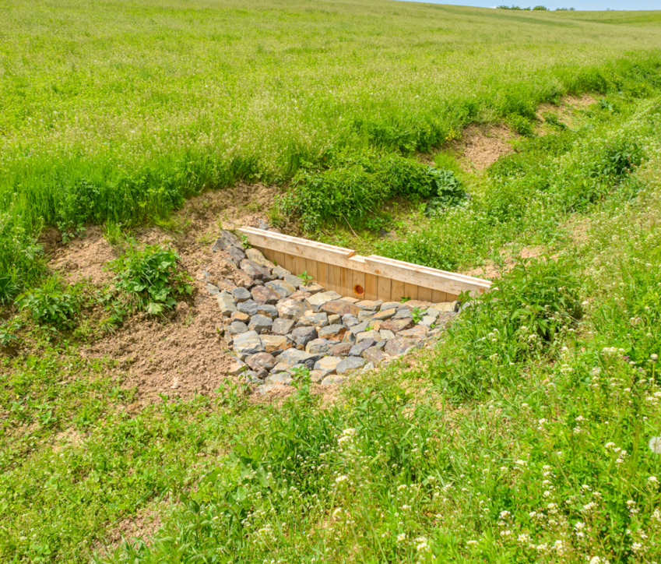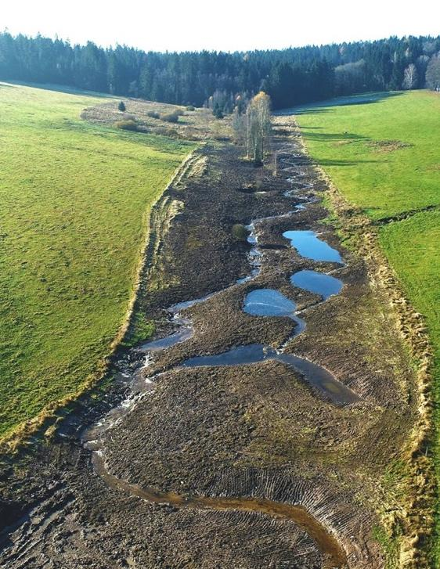
Figure 18. Revitalization of the Žandrak – example of small dams on the flow (left) and revitalisation of embankments (right) (Source: Lesy ČR)

Introducing specific management rules
The introduction of specific management rules for the Tišina protected area is necessary to ensure effective and long-term protection and sustainable use. A well-prepared management plan will establish clear zonation within the site and distinguish areas that require strict protection from those that may allow regulated activities. This structured approach will balance nature conservation with sustainable development, ensuring that the ecological integrity of Tišina is maintained while addressing the needs of local communities.
In practice, the implementation of these guidelines in Republika Srpska would require a revision of the existing legal framework governing Tišina to define new zoning, management priorities and responsibilities of the management authority. Strengthening law enforcement would be essential to ensure that regulations are complied with and that all activities in the area are in line with nature conservation standards. Working with local authorities and stakeholders can facilitate this process and promote a shared commitment to site protection. Such structured and legally sound management can support ecological restoration efforts, prevent illegal activities and contribute to the overall resilience and sustainability of Tišina as a protected area. Improved management rules for Tišina PA includes:

Revision of the existing legal framework
The current legal framework governing Tišina should be revised to reflect the updated zonation, management priorities, and responsibilities. Key changes include:
Zonation
Define strict protection zones where human activity is prohibited, buffer zones for limited, regulated activities, and sustainable use zones for eco-tourism and educational purposes. See the proposal of zonation in chapter 3.3.2.

Clear management objectives and update of management plan
Specify conservation goals, such as maintaining water levels, controlling invasive species, and preserving critical habitats for flora and fauna. This in practical means introduction of the conservation objectives and described in Box 3. Furthermore we suggest updating the current management plan. It will be done based on the recommendation from this document and will reflect mainly the new proposed zonation, management of the water levels, monitoring specifications etc.
Integration of restoration measures
Incorporate all seven restoration measures as proposed in this chapter and put them in practical realization via direct plan of restoration.

Strengthening law enforcement
Effective law enforcement is critical for protecting Tišina against illegal activities, such as poaching, unauthorized land use, or waste disposal. This involves:
- Training and deploying enforcement officers equipped with tools for monitoring and reporting violations.
- Utilizing technology like remote sensing and drones to detect illegal activities.
- Establishing penalties for non-compliance to serve as a deterrent.

Community involvement and stakeholder engagement
Successful management relies on the cooperation of local stakeholders. The management rules should include mechanisms for:
- Stakeholder engagement: Regular consultation with local communities, landowners, businesses, and environmental NGOs to ensure their interests are considered.
- Education and awareness: Conducting workshops and campaigns to educate stakeholders about the ecological and socio-economic benefits of conserving Tišina.

Monitoring and evaluation framework
The law should mandate a robust monitoring system to track the progress of restoration measures and the health of the ecosystem. Key aspects include:
- Installing water level sensors and data loggers to monitor hydrological changes.
- Conducting biodiversity surveys to assess the success of conservation efforts.
- Requiring annual reporting on the implementation of management activities and ecological outcomes.
More on the post-hoc monitoring is described in Chapter 5.

Sustainable Financing
A section of the management plan should focus on sustainable financing to support long-term conservation efforts. Potential funding sources include:
- Government grants and international conservation funds.
- Revenue from ecotourism activities and educational programs.
- Partnerships with private entities invested in sustainable development.

Practical Implementation in Republika Srpska
To implement these rules, the government of Republika Srpska must take the following steps:
- Draft and approve legislative amendments reflecting the updated management plan.
- Initiate stakeholder engagement programs to ensure broad support for the revised rules.
- Secure funding for initial investments in infrastructure, monitoring systems, and enforcement mechanisms.
- Implement a phased approach, starting with immediate actions like sediment removal, wells construction and dam construction, while gradually introducing more complex land use changes and community-based initiatives over the next 5-10 years.

Optimizing land cover
The previous findings led to proposals for further measures, which, unlike the previous ones, consist in limiting the loss of water from the area. In the long term, their implementation will lead to a gradual improvement of the water balance in the area or, at least, will help to stop the deterioration of the situation.
Land cover significantly influences the landscape's ability to retain water and cool the environment. This is also confirmed in the Tišina area. Figure 9 shows a demonstrable temperature difference in selected comparable fields, with field 1, which is near a water body and simultaneously surrounded by mature crops, being cooler. This finding is supported by a range of measured data from other areas. Therefore, it is already possible to recommend with a high degree of certainty efforts to shorten the period during which agricultural land remains bare, without vegetation. This can be addressed, for example, by using cover crops. At the same time, it is desirable to work with mature linear vegetation in the area – hedgerows, tree lines, riparian forests. All these biotopes have a cooling effect, help to close the small water cycle in the landscape, and are an important niche for biodiversity.
A properly functioning small water cycle is an important prerequisite for slowing down of loss, but also returning water to the landscape. Forest play a key role in a well-functioning local small water cycle. The crowns of trees protect the soil from overheating during hot days, and a vertical temperature zonation is created in the stand, which significantly slows down the loss of water from the area. On the contrary, at night, the crowns of trees with a large surface area act as cold surfaces on which air humidity condenses. For this reason, it is desirable in the long term to directly and indirectly motivate (i.e., financially and through education) landowners/farmers to afforest areas. It is necessary to work with local species and avoid introducing non-native, often invasive tree species. Working with pioneer vegetation/trees is appropriate, as they stabilize the soil horizon with sufficient organic matter thanks to the development of mycorrhizal communities, whose essential ability is to retain water in the soil.

Changing land use in protected area
Given that lower surface temperature, based on our measured data, implies higher evapotranspiration, it is also possible to consider the measure of "land use change". In this case, a change in the way agricultural fields are managed. It is possible to consider the utilization of crops other than those currently used in crop rotations, as well as pasture or, for instance, orchards. Finally, it is advisable to consider the utilization of C3 and C4 plants. C3 and C4 plants differ in their photosynthesis processes, which affects their adaptation to various climate conditions. C3 plants use the C3 photosynthetic pathway and thrive in cooler, wetter, and shadier environments typical of temperate regions. Examples of C3 plants include wheat, rice, barley, soybeans, potatoes, and most trees. These plants are less efficient in high temperatures and dry conditions because they lose more water and experience higher photorespiration, which reduces their productivity. In contrast, C4 plants use the C4 photosynthetic pathway, which allows them to minimize water loss and reduce photorespiration. C4 plants do best in hot, sunny, and dry conditions, characteristic of tropical and subtropical regions. Examples of C4 plants are corn, sugarcane, sorghum, and various grasses. These plants are more efficient than C3 plants in high temperatures and arid conditions, making them suitable for cultivation in arid areas or during the hot season. In agriculture, the choice between C3 and C4 plants depends on the climate and specific environmental conditions, as each type has its own advantages and optimal growth conditions. However, experts recommend communicating the change in farming sensitively, more by education, perhaps by voluntary implementation of changes in cropping practices. The reason is that the area of individual plots is small and the landscape mosaic quite diverse compared to some European countries, including the Czech Republic. Land use changes are directly linked to land cover and, fundamentally, they cannot be separated.
This is particularly crucial from the perspective of forests. Forests are often viewed only as land cover. However, their aforementioned benefits can also be utilized in the management of agricultural land. In addition to the direct production of wood, they create windbreaks in the area (i.e., they limit water loss through direct evaporation from land exposed to prevailing wind directions), help regulate the water balance in the area, cool the landscape, and create conditions for further biodiversity.

Timeline for the implementation
The presented timeline describes in more detail the timeframe for implementing each of the seven measures. This timeline considers a realistic proposal of how each measure will be implemented and how they will build on each other. Experts are also describing estimated costs of each of the Measures phase. It must be noted that each Measure needs to be broken down into three individual parts – 1. Designing, 2. Permitting 3. Practical implementation. Each of the measures is very unique in nature and each of these phases will be differently long, complex and costly.

Removal of sediments in water bodies
- Design (4 months):
- Preparation of precise sediment removal design and projection of the technical solution including analyses of ecological impact.
- Estimated cost: €8,000 for design studies.
- Permitting (6 months):
- Obtain permits for excavation works and clearance from environmental authorities.
- Estimated cost: €2,500 for legal and administrative fees.
- Implementation (4 months):
- Employ dredging equipment to remove sediment.
- Material needs: Dredgers, sediment transport vehicles, agricultural machinery (cooperation with local farmers).
- Conditions for implementation: Cooperation with the local farmers for depositing of sediments onto the soil. The work should be done in the autumn or winter period.
- Estimated cost: €100,000 for equipment and labour.

Building barriers and dams in Mala and Velika Tišina
- Design (6 months):
- Carry out refinement surveys for planning - final geodetic survey, static and engineering geological assessment, hydrology modelling.
- Prepare engineering designs for dams and outflow objects.
- Estimated cost: €25,000 for design and studies.
- Permitting (6 months):
- Engagement of local stakeholders in public hearings.
- Securing urban and construction permits.
- Estimated cost: €4,000 for permitting and consultation.
- Implementation (12 months):
- Procure materials (concrete, reinforcement bars, etc.).
- Proceed with the works.
- Conditions for implementation: Cooperation with the Tišina PA management body in order to follow the protection strategy. The works can be only done in the period of hydrology minimum.
- Estimated cost: In the best case scenario (paved road embankment can be used as a levee) the costs will be approx. €200,000 for materials, labour, and equipment.

Building additional water source for wetland system
- Design (4 months):
- Design of exploratory wells, monitoring wells and piezometers.
- Estimated cost: €3,000 for design.
- Permitting (6 months):
- Obtain necessary permits and public consultation.
- Estimated cost: €1,500 for permitting and consultation.
- Implementation (1 month):
- Construct exploratory wells (manually excavated wells), monitoring wells (drilled wells) and install pumping and monitoring systems.
- Material needs: Drilling equipment, pumps, pipelines, and monitoring equipment.
- Conditions for implementation: Exploratory wells could be turned into permanent wells if no risk is proofed after 2 years of operation.
- Estimated cost: €60,000 for construction and installation.

Clearing of Žandrak
- Design (3 months):
- Develop technical documentation and specifications for clearing and for construction of small dams and embankment revitalization.
- Estimated cost: €4,000 for design documentation.
- Permitting (2 months):
- Secure environmental and water management permits.
- Estimated cost: €1,500 for permitting and legal processes.
- Implementation (6 months):
  - Mobilize machinery and labour for clearing, construction of dams and restoration of river bed.
  - Estimated material needs: Excavators, transport vehicles, and disposal sites.
  - Conditions for implementation: This work must follow the removal of sediment (Measure 1).
  - Estimated cost: €50,000 for equipment rental, labour, and waste disposal.

Introducing specific management rules
- Drafting and stakeholder engagement (6 months):
- Revise legal framework and consult with stakeholders.
- Estimated cost: €10,000 for legal expertise and workshops.
- Approval process (6 months):
- Submit draft rules to authorities and incorporate feedback.
- Estimated cost: €5,000 for legal processing.
- Implementation (Ongoing):
- Increase the workforce capacity of the management body and focus on enforcement of the updated Tišina Management Plan
- Annual operating budget: €20,000 for staffing and equipment.

Optimizing land cover
- Design (12 months):
- Estimate a real possibility of areas for change.
- Suggesting new sites for planting of tree lines, individual trees etc.
- Estimated cost: €15,000 for mapping and analysis.
- Implementation (24 months):
- Introduce appropriate vegetation and manage invasive species.
- Estimated cost: €50,000 for planting and maintenance.

Changing land use in protected area
- Design (18 months):
- Identify areas for land use change and revise legal agreements.
- Process public hearings with stakeholders
- Estimated cost: €10,000 for planning and legal fees.
- Implementation (10 years):
- Transition land to designated uses through incentives and management.
- Estimated cost: €50,000 for incentives and monitoring.

Overall timeframe and costs
Below are summarized the outputs of the assessment of the time and financial requirements for the implementation of the PA Tišina Restoration Plan. As it can be seen from Table 8, the time requirement for the implementation of the first 4 measures, which are key in terms of the revitalisation of the area, is at least 24 months. If other measures are included, the horizon extends over a period of years. If the periodic costs of compliance and control of management rules (estimated at 20 000 €/year) are not considered, then the total estimated cost of implementing all measures is up to €600,000.
Table 8. Summary of the restoration timeline and estimated costs
Measure | Phase | Start (Months from start) | End (Months from start) | Estimated financial needs (€) | Subtotal (€)
Removal of Sediments | Design | 0 | 4 | 8 000 € | 110 500 €
Removal of Sediments | Permitting | 5 | 10 | 2 500 € | 110 500 €
Removal of Sediments | Implementation | 11 | 14 | 100 000 € | 110 500 €
Building Barriers and Dams | Design | 0 | 6 | 25 000 € | 229 000 €
Building Barriers and Dams | Permitting | 7 | 12 | 4 000 € | 229 000 €
Building Barriers and Dams | Implementation | 13 | 24 | 200 000 € | 229 000 €
Building Additional Water Source | Design | 0 | 4 | 3 000 € | 64 500 €
Building Additional Water Source | Permitting | 5 | 10 | 1 500 € | 64 500 €
Building Additional Water Source | Implementation | 11 | 12 | 60 000 € | 64 500 €
Clearing of Žandrak | Design | 0 | 3 | 4 000 € | 55 500 €
Clearing of Žandrak | Permitting | 4 | 5 | 1 500 € | 55 500 €
Clearing of Žandrak | Implementation | 13 | 18 | 50 000 € | 55 500 €
Introducing Management Rules | Drafting and Engagement | 0 | 6 | 10 000 € | 15 000 €
Introducing Management Rules | Approval Process | 7 | 12 | 5 000 € | 15 000 €
Introducing Management Rules | Implementation | 12 | Ongoing | 20 000/year | 15 000 €
Optimizing Land Cover | Design | 6 | 18 | 15 000 € | 65 000 €
Optimizing Land Cover | Implementation | 18 | 42 | 50 000 € | 65 000 €
Changing Land Use | Design | 6 | 24 | 10 000 € | 60 000 €
Changing Land Use | Implementation | 25 | Ongoing | 50 000 € | 60 000 €

The Gantt chart below illustrates the sequence and timing of the steps leading to the implementation of this restoration plan.
Figure 19. Gantt chart of the restoration steps (Source: Authors)

Best methods for conducting restoration measures
In this chapter, the topic of discussion are the various conditions that need to be taken into account when implementing individual measures to ensure the protection of the interests of all stakeholders and especially the protection of the environment, i.e. the rare ecosystems in Tišina. It is clear that for successful completion of implementation, all measures must be implemented in accordance with all applicable standards and laws, both at the level of Bosnia and Herzegovina, entity Republika Srpska, and within the framework of international conventions. Annex 1 accurately summarizes all these standards that must be complied with at all costs. This is not an exhaustive list, since, as can be seen from the description of the measures, the proposed solutions very often concern various construction or hydrogeological works. For this reason, it is necessary to comply with a number of national regulations that define and regulate, in particular, the construction sector and general environmental protection. The restoration of the Tišina protected area is a sensitive issue that requires a precise combination of an ecological approach, technical solutions and compliance with local regulations. The design team's approach to the proposal is that this comprehensive approach must include careful planning and design, careful selection of technical implementation measures and strategic timing of activities, minimisation of ecological impact and responsible disposal of materials.
Thorough planning and design is the foundation of the restoration process. The developed Restoration Plan has defined the locations where excavation and other interventions should occur, based on the extensive hydrological and ecological assessment presented in this document. However, none of the interventions can practically be carried out without a proper and legally defined elaboration of the procedure for carrying out the intervention. This makes it prudent to develop project documentation that will include different levels of permitting depending on the type of intervention - urban permit, construction permit, water permit, etc. The authoring team strongly recommends that these documents will be developed in accordance with this document (i.e., the mandatory basis for the selection of the contractor will be this restoration plan) and the authoring team will have the opportunity to supervise the executed output.
Certainly, the implementation itself should be carried out in accordance with the necessary environmental protection. The selection of machinery and equipment is a critical component that directly affects the environmental impact of the project. The selection of machinery will emphasize precision, appropriate size and minimal disruption to the environment. Equipment such as amphibious excavators or low ground pressure machines should be used to move efficiently through the wetland terrain without unnecessarily damaging the soil structure or existing vegetation. Before and during excavation or water level modifications (e.g., draining a wetland), the developer (or investor) must ensure that an assessment is conducted to identify aquatic organisms that cannot move on their own to a suitable alternative location. In the event of their occurrence, salvage transfer should be ensured. If invasive species are found, the investor shall ensure their eradication by a competent person. On the basis of the above assessment, a suitable period for follow-up work will also be determined. The result of the assessment, including a proposal for any salvage transfer and eradication measures and a proposal for an appropriate start date for the discharge, shall be submitted by the investor to the local nature conservation authority prior to the commencement of the works for approval and for the determination of the period for carrying out the necessary measures and for the determination of the start date for the works. At the same time, it shall submit to the local nature conservation authority an agreement with the authorised person for the implementation of any rescue transmission and the provision of any eradication measures.
Another key factor in minimising the ecological impact of restoration activities is timing, taking into account critical breeding periods, migration periods and other sensitive periods in the life cycles of key species. Construction work can be carried out in phases, allowing wildlife undisturbed refuge. This phased approach will ensure continued habitat availability and reduce stress on animal populations. Minimizing ecological impact applies not only to the timing, but also to the methods used in restoration. Strategies will be put in place to protect amphibians, fish, birds and other wildlife from potential harm. This may include, in particular, the creation of escape routes for animals within work zones. Best practice in water quality management will be strictly adhered to, including measures to control erosion and prevent contamination of water bodies. Soil stability will be maintained through careful excavation techniques and immediate re-establishment of vegetative cover where possible.
Responsible planning for the disposal of excavated materials is essential to avoid secondary environmental problems. Prior to disposal, the materials will be subjected to chemical analysis to determine their composition and possible contaminants. Based on these findings, suitable destinations for the materials will be identified. uncontaminated materials may be reused in the restoration project, for example to create habitat features such as berms or islands that increase ecological diversity. Contaminated materials will be disposed of in accordance with environmental regulations at approved facilities, ensuring that they do not contribute to habitat destruction or pollution elsewhere.
Compliance with local laws and regulations is a guiding principle throughout the restoration process. The project will comply with the Law on Water, the Law on Nature Protection and all other relevant legislation of the Republika Srpska. All necessary permits and approvals will be secured in cooperation with the relevant authorities, including the Ministry of Agriculture, Forestry and Water Management and the Ministry of Spatial Planning, Construction and Ecology. Collaboration with local communities and stakeholders is also an important aspect to promote transparency, build trust and incorporate valuable local knowledge into the project.
At the same time, experts recommend that generally accepted standards for the proper implementation of site restoration be followed at all stages of preparation and implementation. For example, the International Principles & Standards for the Practice of Ecological Restoration.

Post-hoc monitoring
The restoration of the Tišina protected area is an effort to address ecological and hydrological problems while ensuring the long-term sustainability of rare water-dependent ecosystems. In order to achieve the set objectives, on the one hand, it is necessary to implement the proposed measures. However, due to the complexity of the area, these may not be sufficient in themselves or may require more additional work, which is not considered in this document as the circumstances requiring them are not known to the authors at this time. It is therefore essential to define an effective follow-up monitoring programme for the measures and the site as a whole, which will provide tools to evaluate the success of the measures implemented and allow adaptive management if necessary. Monitoring will focus on multiple aspects, thus ensuring a holistic approach to conservation:
- Hydrological stability
- Biodiversity restoration
- Water quality
- Socio-economic impacts of restoration
Central to the plan is hydrological monitoring, which will track changes in water levels in the Velika Tišina, Mala Tišina and the Žandrak Channel. This must be based on the project for a replacement water source for the Tišina (Measure 2 - see chapter 4). Automatic water level loggers will be installed at key locations to provide continuous data, supplemented by manual measurements to verify the results. Groundwater dynamics will also be monitored using piezometers near the newly constructed wells to assess the sustainability of water abstraction. These data will be analysed at monthly intervals to ensure early detection of any imbalances that could affect the water regime of the wetland. Monitoring will be most intensive during the first two years, when it must be determined whether groundwater pumping is a seriously appropriate way of replenishing the wetlands. Gradually, there will be a shift to less frequent assessments as conditions stabilize.
Biodiversity restoration is equally critical, as the success of restoration depends on the return or maintenance of key species and habitats. Semi-annual field surveys will assess the diversity and population trends of amphibians, reptiles, birds and fish. These surveys will be supplemented with modern tools such as camera traps and acoustic monitoring devices to provide information on nocturnal and elusive species. Vegetation health and cover will be monitored using drone technology, allowing for accurate assessment of planted areas and early detection of invasive species. This comprehensive approach will ensure that the ecological benefits of restoration are thoroughly documented and maintained. Experts also recommend monitoring of habitat development.
Water quality monitoring will further support the assessment of restoration success by focusing on parameters such as turbidity, dissolved oxygen, pH and nutrient concentrations. Monthly sampling at critical points will provide a detailed picture of water conditions, allowing identification of any problems that may arise during or after restoration. Laboratory analysis of sediment and water samples will help monitor changes over time and guide future management decisions. This monitoring will be particularly important in areas affected by sediment removal, as it will ensure that the intervention does not negatively impact water quality or aquatic life.
Socio-economic impacts will also be monitored to assess the impact of restoration on local communities and stakeholders. Annual surveys and interviews will gauge community satisfaction, monitor the success of land use changes and assess ecotourism development. These findings will inform adaptive management strategies and help balance conservation objectives with the needs of local people.
The success of this monitoring programme depends not only on data collection, but also on data analysis and use. Findings will be compiled into annual reports for stakeholders and regulators, ensuring transparency and encouraging collaboration. These reports will guide the governing body in refining recovery actions and addressing emerging issues. The programme will require significant resources, including modern equipment such as drones and water level recorders, as well as a dedicated team of hydrologists, ecologists and engineers. The operational costs will be offset by the invaluable knowledge gained to ensure the long-term success of the restoration.
Table 9. Overview of monitoring measures
Type of Monitoring | Types of measurements | Equipment or types of surveys | Professions involved
Hydrological | Water level changes in Velika Tišina, Mala Tišina, Žandrak Canal | Automatic water level loggers, manual measurement tools, manual gauging station | Hydrologist, technician
Hydrological | Groundwater dynamics near wells | Piezometers with dataloggers | Hydrogeologist, technician
Biological/Ecological | Habitat monitoring | Field surveys, drone imagery | Ecologist, field biologist
Biological/Ecological | Species diversity and population trends of amphibians, reptiles, birds, and fish | Camera traps, acoustic sensors, field guides | Ecologist, field biologist
Biological/Ecological | Vegetation health and cover | Drones with multispectral cameras | Botanist, drone operator
Biological/Ecological | Presence of invasive species | Field surveys, drone imagery | Ecologist, drone operator
Water quality | Turbidity, dissolved oxygen, pH, nutrient concentrations | Portable water quality meters, sampling kits | Water quality specialist, technician
Water quality | Laboratory analysis of water and sediment samples | Laboratory facilities, sediment and water analysis kits | Chemical laboratory technicians

Evaluation of the restoration plan
As part of the objectification process, a SWOT analysis was prepared for each measure. The SWOT analysis will be made available to all stakeholders for comments. SWOT analysis is a strategic planning tool used to identify and evaluate project’s internal strengths and weaknesses, as well as external opportunities and threats, to inform effective decision-making and strategy development.

Simplified SWOT analysis

Removal of sediments in water bodies
This measure will be fast and with long term effect on the ecosystem.
Strengths | Weaknesses
Increases water retention capacity, enhancing drought resilience  Reduces excess nutrients, helping to improve water quality | Financially costly, requiring significant resources  Potential risk of disturbing existing functional biotopes, such as islands and peninsulas
Opportunities | Threats
Creation of additional habitat areas beneficial to biodiversity  Formation of small islands or micro-habitats for diverse species | Risk of disrupting settled aquatic ecosystems  Possible re-invasion by nutrient-dependent species after dredging.

Building barriers and damns in Mala and Velika Tišina
This measure will be fast and with short term effect on the ecosystem.
Strengths | Weaknesses
Improves water retention within the wetland, supporting summer water supply  Allows for better regulation of water levels to benefit wetland ecosystems | Only effective in years with sufficient water input.  Heavily dependent on annual weather conditions, making effectiveness variable
Opportunities | Threats
Supports zooplankton growth by limiting fish presence in some areas  Increases mineralization through regulated water levels, enriching the ecosystem | Risk of vandalism or tampering with barriers.  Possible resistance from stakeholders viewing the area as agricultural land rather than a wetland.

Building additional water source for Wetland system
This measure will be fast and with short term effect on the ecosystem.
Strengths | Weaknesses
Provides a reliable, cost-effective water source, especially in dry seasons  Establishes a permanent water source, helping to maintain wetland stability | Uncertain yield; two years of well monitoring required to confirm sustainability  Initial testing and setup phases require time and resource investment
Opportunities | Threats
Enhances understanding of groundwater fluctuations, beneficial for both restoration and local water management  Promotes biodiversity by stabilizing water levels in critical habitats | Potential risk of connecting aquifers, leading to unintended water losses  Possibility of depletion if aquifer recharge rates are low

Clearing of Žandrak
This measure will be fast and with medium term effect on the ecosystem.
Strengths | Weaknesses
Enhances water retention in Tišina, benefiting surrounding landscapes  Low-cost intervention with a high potential ecological return | Impact depends on water availability; effect limited in drought conditions
Opportunities | Threats
Boosts biodiversity by removing waste and restoring natural flow  Supports a fish-free area, fostering zooplankton and other beneficial species | Invasion by non-native species in cleared channels  Rapid infiltration of water into the soil may reduce visible water retention

Introducing specific management rules
This measure will be long in implementation and with medium to long term effect on the ecosystem.
Strengths | Weaknesses
Supports biodiversity by establishing clear conservation and management protocols  Helps sustain fish-free zones that can serve as habitats for other species | Challenging to enforce consistently, especially in isolated areas  Managing a balanced approach to both human and ecological needs is complex
Opportunities | Threats
Establishes cultivation zones for zooplankton, supporting ecosystem food chains  Reduces fishing-related disturbances, preserving the ecological balance | Resistance from local stakeholders reliant on the area for economic activities  Requires continuous stakeholder engagement to maintain compliance

Optimizing land cover
This measure will be long in implementation and with long term effect on the ecosystem.
Strengths | Weaknesses
Reduces evapotranspiration, retaining water in the landscape longer  Supports biodiversity by introducing more water-retentive vegetation | Requires changes to existing land-use practices, which may face resistance  Increases logistical requirements for implementation and maintenance
Opportunities | Threats
Allows introduction of new, ecologically compatible crops  Reduces frequency of agro-technical interventions, potentially lowering costs | Potential for new crop-associated pests to establish in the area  Long-term transition may be challenging for local farming operations

Changing land use in protected area
This measure will be long in implementation and with long term effect on the ecosystem.
Strengths | Weaknesses
Limits water loss through reduced evapotranspiration, supporting wetland stability  Encourages biodiversity through the introduction of habitat-supportive practices | Initial reluctance from landowners to change traditional farming practices.  Transition process may demand intensive planning and adaptation
Opportunities | Threats
Offers potential for new, wetland-supportive crops that enhance biodiversity  Reduces need for extensive agro-technical measures, supporting sustainability | Increased risk of pests adapted to wetland agriculture  Market challenges if new crops are not economically viable

Conclusions
The Tišina Protected Area, a unique wetland complex influenced by the Bosna and Sava rivers, has been facing significant environmental challenges in recent decades, mainly due to water scarcity caused by climate change, land use changes and water management practices. These changes have led to the drying up of the water bodies in the complex, with the Mala Tišina wetland being the most severely affected, with an almost complete collapse of the system. In Velika Tišina and Odmut, water levels are fluctuating drastically and there is a risk of complete drying up by the end of summer. Given the valuable biodiversity and essential flood control functions, the conservation of the Tišina is critically important and immediate action is required to reverse these negative trends.
This restoration plan has been developed based on an in-depth analysis and understanding of the natural dynamics of the Tišina wetlands and the anthropogenic factors that have altered their functionality. The basic principle of its preparation is the restoration of ecological balance, but it also aims to promote sustainable human interaction with the landscape in the densely populated Posavina region.
The core of the restoration plan is to counter the impacts of drying trends and land use changes that ultimately threaten biodiversity and the ecosystem services that Tišina provides. Key measures proposed include partial sediment removal to increase water retention (applicable to water body of Mala Tišina and Žandrak channel), construction of barriers and dams to regulate water levels and, most importantly, implementation of new water sources that will lead to mitigation of seasonal water shortages. These technical interventions are complemented by other ecological strategies such as optimizing land cover, introducing management rules and adjusting land use patterns. Together, these measures aim to restore critical habitats, support water-dependent biocenoses and create a resilient wetland system that can withstand climatic fluctuations.
The plan also emphasises the integration of rigorous monitoring, scientific oversight and adaptive management as essential tools to ensure the long-term success of restoration efforts. Ongoing hydrological monitoring, biodiversity assessments and socio-economic evaluations will provide actionable insights that will allow for iterative improvement of interventions. In addition, the zonal approach outlined in the plan provides clear management principles that balance conservation priorities with sustainable resource use.
To ensure consistency with wider environmental objectives, this restoration initiative has been designed to complement the objectives of the Sava River Basin Plan. By addressing issues such as water quality, flood mitigation and habitat connectivity, the Tišina restoration supports regional and international commitments to biodiversity conservation and sustainable water management.
The success of restoration depends on effective collaboration between stakeholders, reliable funding mechanisms. It is essential to maintain momentum in the implementation of the outlined measures while encouraging community involvement and support to ensure their lasting impact. If carefully implemented, these wetlands have the potential to serve as a model of ecological restoration that balances human needs with the preservation of a fragile and irreplaceable ecosystem.

Annexes

Annex 1. Summary review of the past studies
Annex 2. Hydrogeological survey
Annex 3. Geodetic survey
Annex 4. Study on the local climatic conditions
Annex 5. Analysis of sediment content and quality

References

- Ripl, W. (1995): Management of water cycle and energy flow for ecosystem control: The Energy-Transport-Reaction model (ETR). Ecol. Modelling 78:61-76.
- Ripl, W., Hildmann, Ch. (2000): Dissolved load transported by rivers as an indicator of landscape sustainability. Ecol Eng 14:373-387.
- Chytrý M., a kol. (2010): Katalog biotopů České republiky
https://www.sci.muni.cz/botany/chytry/Chytry_etal2010_Katalog-biotopu-CR-2.pdf
- de Groot, R. S., Wilson, M. A., Boumans, R. M. J. (2002) A Typology for the Classification, Description and Valuation of Ecosystem Functions, Goods and Services. Ecological Economics, 41(3), pp. 393-408.
- Sejak, J.; Cudlin, P.; Pokorný, J.; Zapletal, M.; Petricek, V.; Guth, J.; Chuman, T.; Romportl, D.; Skorepova, I.; Vacek, V.; et al. (2010). Valuing Ecosystem Functions and Services in the Czech Republic. FoE UJEP, Usti nad Labem. Available online: http://fzp.ujep.cz/projekty/valuingecosystemservices.pdf
- Ripl, W. (2003) Water: the bloodstream of the biosphere. Phil. Trans. R. Society, London B 358: 1921 - 1934.
- Seják, J., Pokorný, J. and Senay, K. (2018). Achieving Sustainable Valuations of Biotopes and Ecosystem Services. Sustainability 10, 4251; doi:10.3390/su10114251
- Pokorný, J., Seják, J. (2009). Voda a peněžní hodnocení biotopů a služeb ekosystémů (Water and monetary evaluation habitats and ecosystem services). Vodní hospodářství 1, 14-16.
- Sejak, J.; Dejmal, I.; Petricek, V.; Cudlin, P.; Michal, I.; Cerny, K.; Kucera, T.; Vyskot, I.; Strejcek, J.; Cudlinova, E.; et al. Valuation and Pricing Biotopes of the Czech Republic; Czech Environmental Inst.: Prague, Czech Republic, 2003; 450p, (In Czech). Available online: http://fzp.ujep.cz/
- Gann GD, McDonald T, Walder B, Aronson J, Nelson CR, Jonson J, Hallett JG, Eisenberg C, Guariguata MR, Liu J, Hua F, Echeverria C, Gonzales, EK, Shaw N, Decleer K, Dixon KW. 2019. International principles and standards for the practice of ecological restoration. Second edition.Restoration Ecology S1-S46

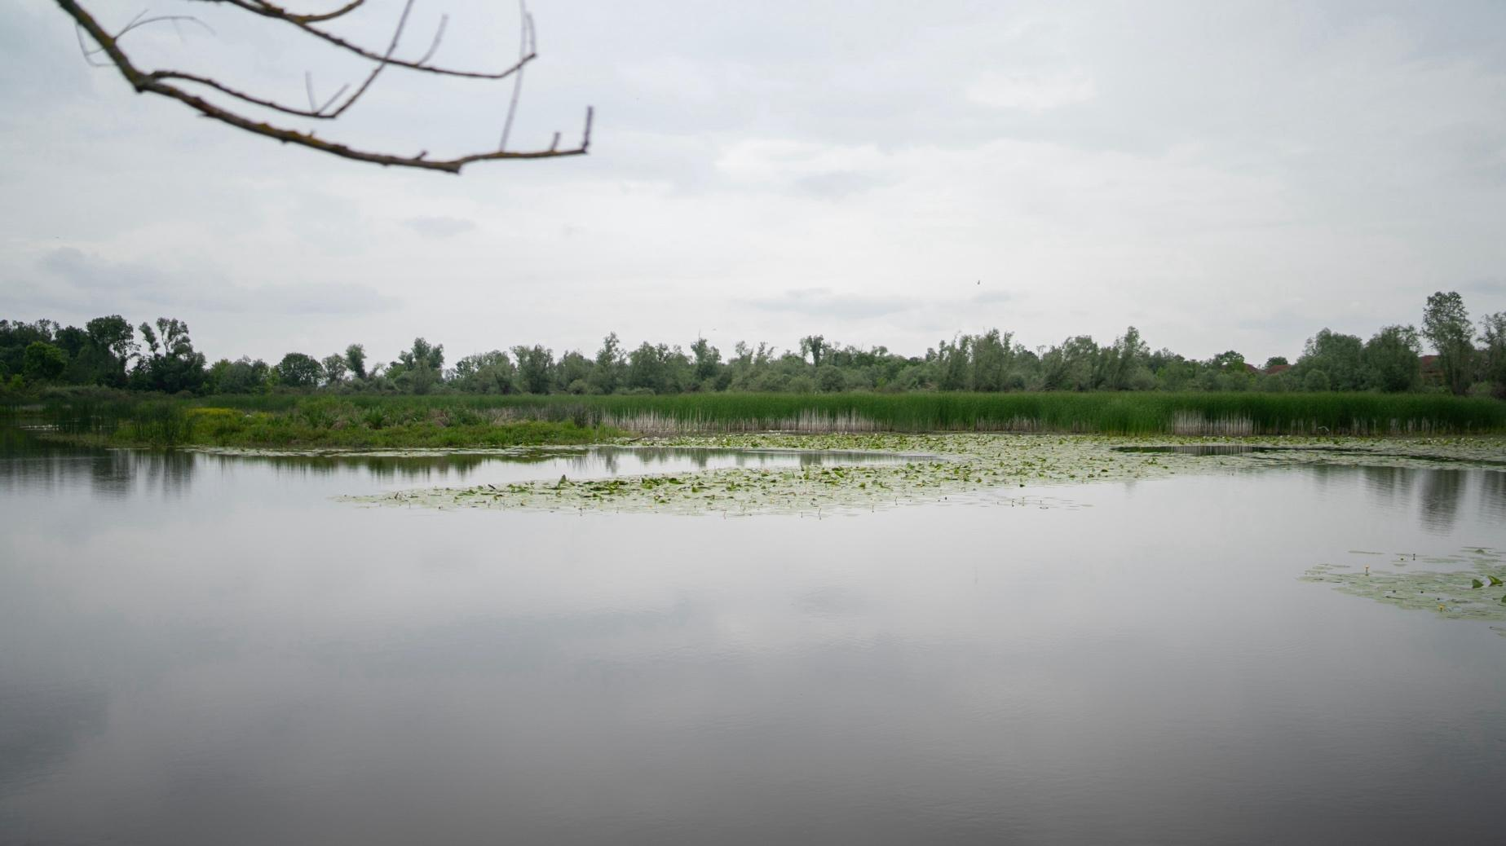

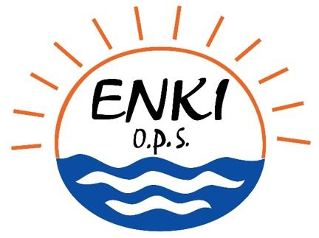

Deliverable 4 - Restoration plan.
1st version

In Třeboň and Sarajevo, 12/2024

Društvo za istraživanje i zaštitu biodiverziteta (2016)._Inventarizacija i uspostavljanje monitoringa biodiverziteta u cilju zaštite bare Tišina u plavnom području rijeke Save. Project financed by the Euronatur, The Aage V. Jensen Foundation, Umweltstiftung Michael Otto.
dtto
Ripl, W. (1995): Management of water cycle and energy flow for ecosystem control: The Energy-Transport-Reaction model (ETR). Ecol. Modelling 78:61-76.
Ripl, W., Hildmann, Ch. (2000): Dissolved load transported by rivers as an indicator of landscape sustainability. Ecol Eng 14:373-387.
Chytrý M., a kol. (2010): Katalog biotopů České republiky https://www.sci.muni.cz/botany/chytry/Chytry_etal2010_Katalog-biotopu-CR-2.pdf
de Groot, R. S., Wilson, M. A., Boumans, R. M. J. (2002) A Typology for the Classification, Description and Valuation of Ecosystem Functions, Goods and Services. Ecological Economics, 41(3), pp. 393-408.
Sejak, J.; Cudlin, P.; Pokorný, J.; Zapletal, M.; Petricek, V.; Guth, J.; Chuman, T.; Romportl, D.; Skorepova, I.; Vacek, V.; et al.(2010). Valuing Ecosystem Functions and Services in the Czech Republic. FoE UJEP, Usti nad Labem. Available online: http://fzp.ujep.cz/projekty/valuingecosystemservices.pdf
Ripl, W. (2003) Water: the bloodstream of the biosphere. Phil. Trans. R. Society, London B 358: 1921 - 1934.
Seják, J., Pokorný, J. and Senay, K. (2018). Achieving Sustainable Valuations of Biotopes and Ecosystem Services. Sustainability 10, 4251; doi:10.3390/su10114251
Pokorný, J., Seják, J. (2009). Voda a peněžní hodnocení biotopů a služeb ekosystémů (Water and monetary evaluation habitats and ecosystem services). Vodní hospodářství 1, 14-16.
Sejak, J.; Dejmal, I.; Petricek, V.; Cudlin, P.; Michal, I.; Cerny, K.; Kucera, T.; Vyskot, I.; Strejcek, J.; Cudlinova, E.; et al. Valuation and Pricing Biotopes of the Czech Republic; Czech Environmental Inst.: Prague, Czech Republic, 2003; 450p, (In Czech). Available online: http://fzp.ujep.cz/
Law on waters ("Official Gazette of RS", no. 50/2006, 92/2009, 121/2012, and 74/2017) / Zakon o vodama ("Službeni glasnik RS", br. 50/2006, 92/2009, 121/2012 i 74/2017)
Law on Nature protection of RS („Official Gazette of Republika Srpska“ no. 49/24)/ Zakon o zaštiti prirode („Službeni glasnik RS“ br. 49/24)
Gann GD, McDonald T, Walder B, Aronson J, Nelson CR, Jonson J, Hallett JG, Eisenberg C, Guariguata MR, Liu J, Hua F, Echeverria C, Gonzales, EK, Shaw N, Decleer K, Dixon KW. 2019. International principles and standards for the practice of ecological restoration. Second edition.Restoration Ecology S1-S46

